FAST – National University of
Computer and Emerging Sciences
Department of Data Science
CRICLYTICS
Context-Aware Cricket Analytics & Probability Platform
Iteration 3 / Sprint 3 — Final Report
Subject | Fundamentals of Software Engineering
Team Member | Muhammad Ali Aamir │ Roll No. 24L-2558
Team Member | Muhammad Mahad Mahmood │ Roll No. 24L-2548
Deliverable | Iteration 3 / Sprint 3
  Date | May 2026

Website URL: https://criclytics.aliamirchoudhary.workers.dev/

1. Project Introduction

1.1 Project Title
Cricklytics — Context-Aware Cricket Analytics & Probability Platform

1.2 Introduction
Cricklytics is a next-generation cricket analytics platform that bridges the gap between historical data and future predictions. By leveraging the vast Cricsheet international database and custom-trained Machine Learning models, Criclytics provides fans, analysts, and stakeholders with deeper insights than a traditional scoreboard. It transforms raw delivery data into "Mega-Enriched" narratives, offering everything from side-by-side player comparisons to real-time win probabilities.
The platform covers all three major international formats — T20I, ODI, and Test — with dedicated sections for Players, Teams, Venues, Matches, Rankings, Records, Compare, and Search. A built-in Machine Learning probability engine trained on Logistic Regression powers the insight layer.

Layer | Technology
Backend | Python 3.11 · Flask · pandas · scikit-learn · JSON cache
Frontend | HTML5 · CSS3 · Vanilla JavaScript · Font Awesome 6
Data Sources | Cricsheet (CC BY-SA 4.0) · Cricbuzz via RapidAPI · CricAPI · ICC Rankings
ML | scikit-learn Logistic Regression · .pkl model persistence · offline training
Deployment | Hugging Face Spaces (Python SDK) · Cloudflare Workers (Frontend)
Tooling | Git · GitHub · Trello · VS Code

2. Sprint Backlog — Iteration 3

2.1 Modules Developed in Sprint 3

# | Module | Description
M1 | Player vs Player Comparison | Full side-by-side career and format-wise comparison tool with ML probability overlays.
M2 | Team vs Team Comparison | Head-to-head (H2H) win/loss analytics with venue-specific breakdown.
M3 | Global Search System | Persistent header search bar with categorized results and debouncing.
M4 | Rankings & Records | Dynamic ICC-style rankings and filterable all-time records section.
M5 | Mega-Enrichment Pipeline | Pre-enrichment of 6,200+ matches into a single optimized completed_matches.json.
M6 | UI/UX Polish | Dark-mode aesthetic, card-based layouts, mobile responsiveness across all pages.
M7 | Production Deployment | Hugging Face Spaces deployment with smart path logic and manual large-file upload.
M8 | Documentation & Testing | README, API reference, BVA testing, integration & regression tests.

2.2 User Stories — Sprint 3
All user stories are written in the standard Connextra format: As a [role], I want [goal], so that [reason/benefit].

US-15 — Player vs Player Comparison Tool
Field | Detail
User Story ID | US-15
Title | Player vs Player Comparison Tool
User Story | As a cricket fan, I want to select two players and view a side-by-side comparison of their statistics and ML predictions, so that I can make an informed assessment of who performs better in any format.
Sub-story US-15a | As a user, I want a searchable player selection UI (search + dropdown) so that I can find any player from the database quickly.
Sub-story US-15b | As a user, I want a side-by-side stats layout (Runs, Wickets, Avg, SR) so that key metrics are directly comparable.
Sub-story US-15c | As a user, I want format-wise tabs (T20, ODI, Test) so that I can narrow the comparison to a specific format.
Sub-story US-15d | As a user, I want venue and opposition performance overlays so that contextual matchup data is visible.
Sub-story US-15e | As a user, I want ML probability comparison bars (e.g., chance of 50+) so that predictive insights are part of the comparison.

US-16 — Team vs Team Comparison Tool
Field | Detail
User Story ID | US-16
Title | Team vs Team Comparison Tool
User Story | As a cricket analyst, I want to select two teams and compare head-to-head records and win probability insights, so that I can understand team dominance across formats and venues.
Sub-story US-16a | As a user, I want a team selection interface so that I can choose any two international sides.
Sub-story US-16b | As a user, I want an H2H win/loss breakdown by format so that format-specific dominance is visible.
Sub-story US-16c | As a user, I want venue-specific comparison (home/away/neutral) so that match conditions are factored in.
Sub-story US-16d | As a user, I want probability insights (likelihood of winning at specific venues) so that data-driven match previews are available.

US-17 — Global Search System
Field | Detail
User Story ID | US-17
Title | Global Search System
User Story | As a user, I want to search for any player, team, venue, or match from any page on the platform, so that I can navigate instantly without browsing through sections.
Sub-story US-17a | As a user, I want a persistent search bar in the global header so that search is always accessible.
Sub-story US-17b | As a user, I want categorized results (Players, Teams, Venues, Matches) so that results are organized and easy to scan.
Sub-story US-17c | As a developer, I want debouncing (2-character minimum trigger) so that the backend is not spammed with single-keystroke API calls.

US-18 — Rankings & Records
Field | Detail
User Story ID | US-18
Title | Rankings & Records
User Story | As a cricket fan, I want to browse ICC-style rankings and explore all-time records with filters, so that I have a comprehensive view of the game's history and current standings.
Sub-story US-18a | As a user, I want team and player rankings (T20, ODI, Test) so that current standings are always visible.
Sub-story US-18b | As a user, I want curated records (Highest scores, Best bowling, Most wickets) so that cricket history is explorable.
Sub-story US-18c | As a user, I want filters by Format, Team, Player, and Venue so that records are searchable and specific.
Sub-story US-18d | As a user, I want clickable records linking to profiles/matches so that I can drill down into any statistic.

US-19 — Mega-Enrichment Data Pipeline
Field | Detail
User Story ID | US-19
Title | Mega-Enrichment Data Pipeline
User Story | As a developer, I want a pre-enrichment pipeline that aggregates 6,200+ match files into a single optimized JSON, so that the app can be deployed on production environments with file-size constraints.
Sub-story US-19a | As a developer, I want process_cricsheet.py to produce a single completed_matches.json with full scorecards, officials, toss details, and partnerships so that no raw files are needed at runtime.
Sub-story US-19b | As a developer, I want smart path fallback logic in app.py so that the backend finds data files in both local (data/processed/) and production (root /) directories without code changes.

US-20 — Production Deployment (Hugging Face Spaces)
Field | Detail
User Story ID | US-20
Title | Production Deployment — Hugging Face Spaces
User Story | As a stakeholder, I want the fully functional application deployed on a publicly accessible production URL, so that the platform can be demonstrated and evaluated.
Sub-story US-20a | As a developer, I want the code (HTML, JS, CSS, Python) pushed via Git to Hugging Face so that version control is maintained.
Sub-story US-20b | As a developer, I want large files (completed_matches.json, ml_models.pkl, scaler.pkl) uploaded manually via the HF Web Interface so that Git's 10MB file limit is bypassed.
Sub-story US-20c | As a developer, I want data/live/*.json excluded from Git tracking via .gitignore so that the repository stays clean in future iterations.

US-21 — UI/UX Polish & Visual Consistency
Field | Detail
User Story ID | US-21
Title | UI/UX Polish & Visual Consistency
User Story | As a stakeholder, I want all pages to be visually consistent, mobile-responsive, and disclaimer-compliant, so that the platform feels professional and trustworthy.
Sub-story US-21a | As a user, I want a unified dark-mode color scheme, typography, and spacing across all pages.
Sub-story US-21b | As a mobile user, I want the card-based UI to scale gracefully for smaller viewports.
Sub-story US-21c | As a user, I want mandatory ML disclaimers on all prediction widgets so that I understand predictions are statistical, not definitive.

US-22 — Documentation
Field | Detail
User Story ID | US-22
Title | Documentation
User Story | As a developer, I want the project fully documented with a README and API reference, so that the codebase is maintainable and understandable.
Sub-story US-22a | As a developer, I want a detailed README.md covering Setup, Data Sources, and ML pipeline steps.
Sub-story US-22b | As a developer, I want an API reference for all backend endpoints.
Sub-story US-22c | As a developer, I want inline code comments for all critical functions.

US-23 — Integration Testing & Bug Fixing
Field | Detail
User Story ID | US-23
Title | Integration Testing & Bug Fixing
User Story | As a developer, I want all modules to work together without breaking existing functionality from Iterations 1 and 2, so that the complete system is stable for production.
Sub-story US-23a | As a developer, I want end-to-end testing of all Iteration 3 features.
Sub-story US-23b | As a developer, I want regression testing on Iterations 1 & 2 features.
Sub-story US-23c | As a developer, I want cross-browser testing and console error cleanup.

3. Design
All UML diagrams below were produced for Iteration 2 and remain applicable to Iteration 3 as the core system architecture was not changed — Iteration 3 extended and enriched the existing design. The same Flask backend, JavaScript frontend, and ML engine structure is preserved.

3.1 Activity Diagrams
Activity Diagram 1 — Player Profile Request Flow
Covers the full lifecycle of a player profile page load: URL parameter validation, Cricsheet stats lookup with 404 fallback, parallel data fetch (yearly / vs_opp / at_venues / meta), photo URL resolution with initials fallback, and ICC rankings sidebar population.
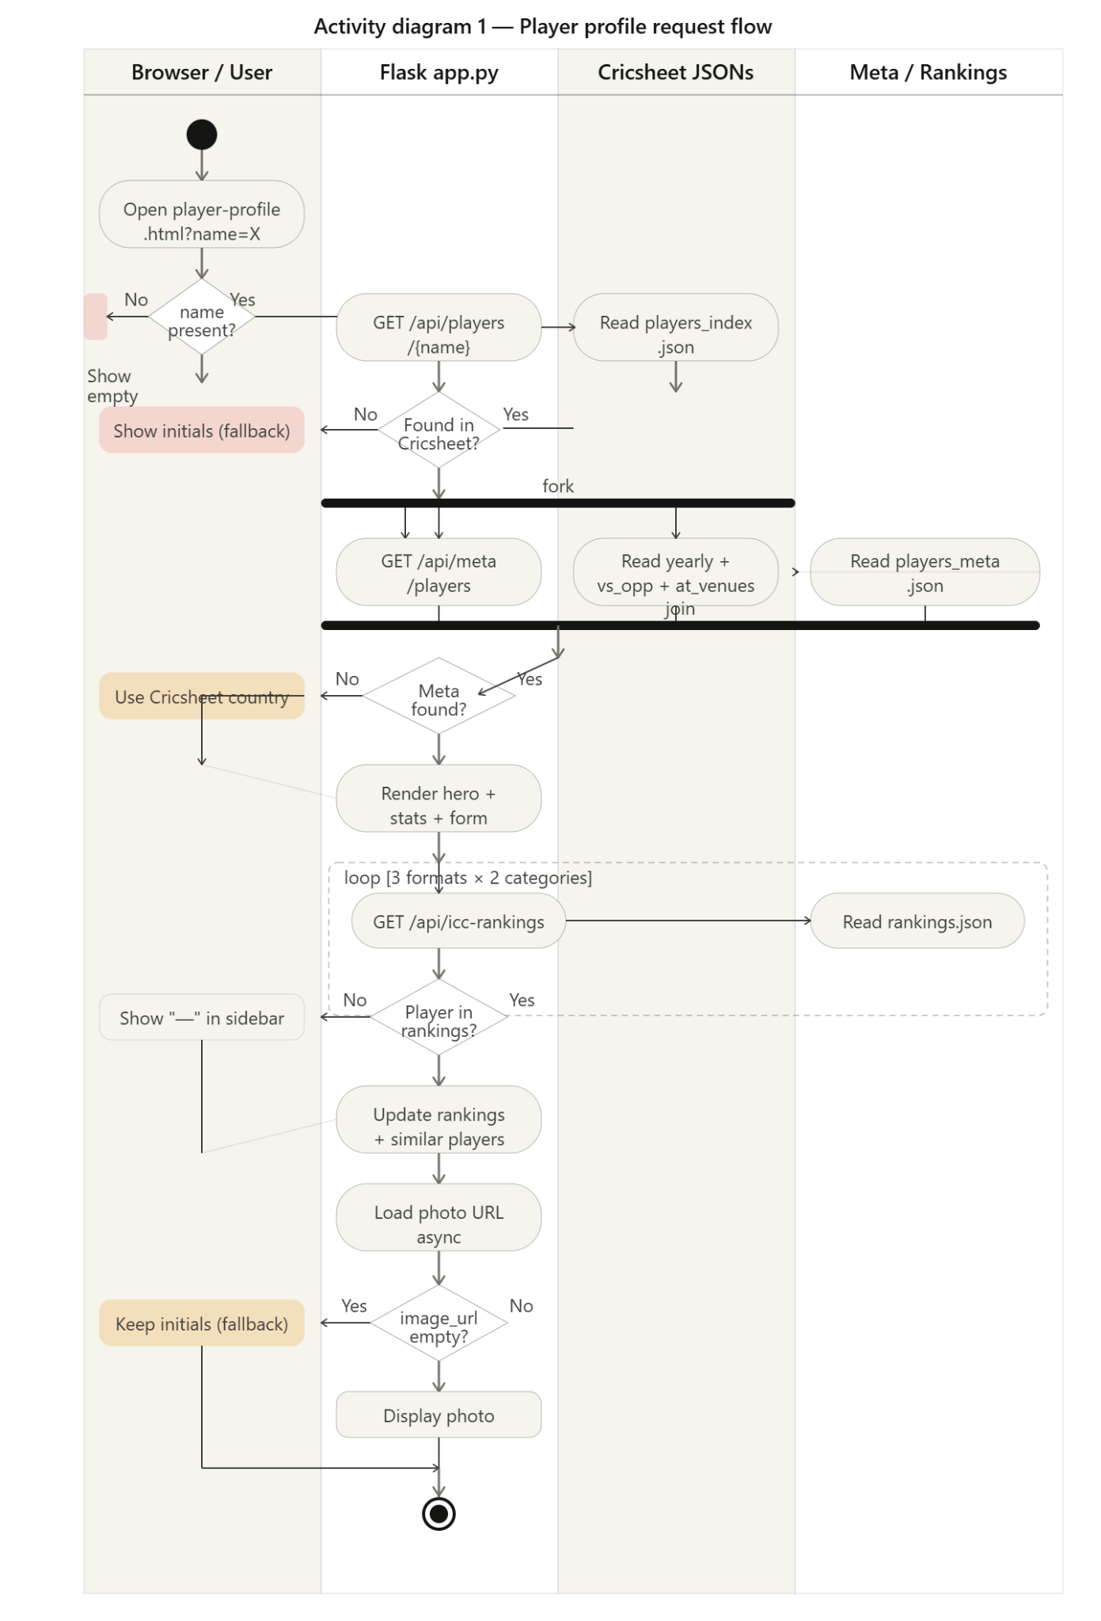

Activity Diagram 2 — Match Data Fetch with Fallback Chain
Covers the matches page data flow: DOMContentLoaded → loading spinner → CricAPI live call → timeout/cache fallback check → cache freshness check (60-minute TTL) → classify into live/upcoming/completed → render three match card groups → pagination (10 per group) → format filter chip wiring.
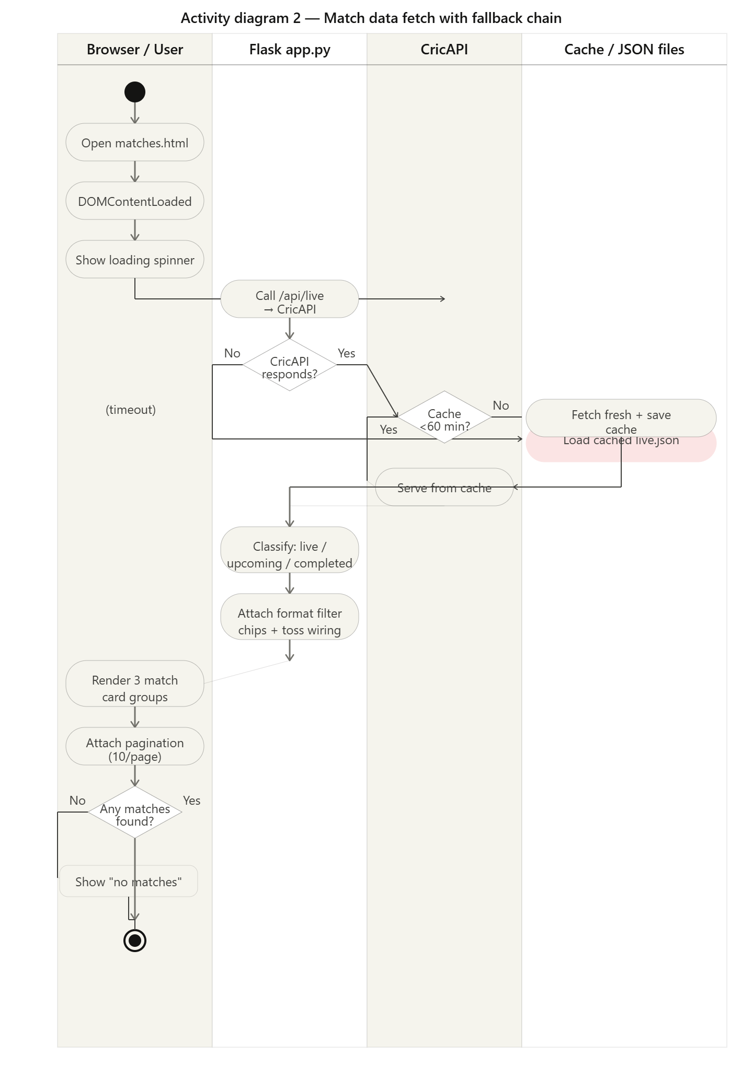

Activity Diagram 3 — Rankings & Records Data Flow
Covers the rankings page lifecycle: format key normalisation (t20 → T20I, odi → ODI, test → Test), 24-hour cache freshness check, live ICC scrape attempt, hardcoded March 2026 fallback, panel injection (batting/bowling/allrounder/teams), and parallel records branch from Cricsheet data.

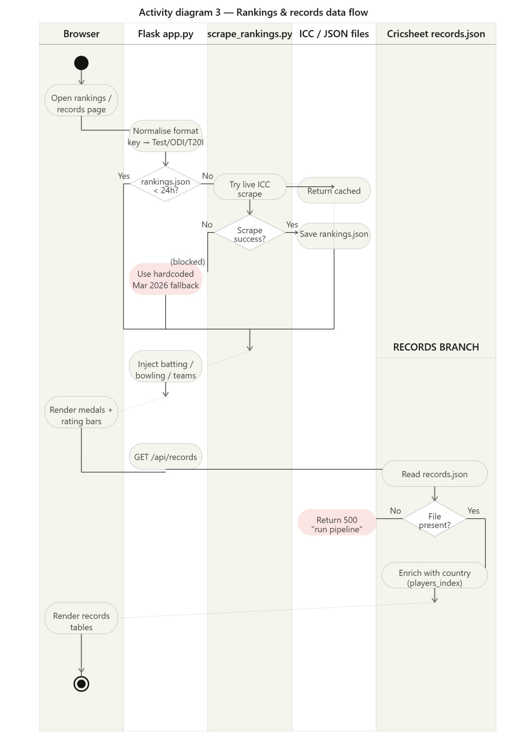

3.2 Use Case Diagram
The use case diagram shows all three actors (End User, Developer, ICC Cricket Website as external system) and all eleven use cases within the Criclytics system boundary, including «includes» and «extends» relationships.

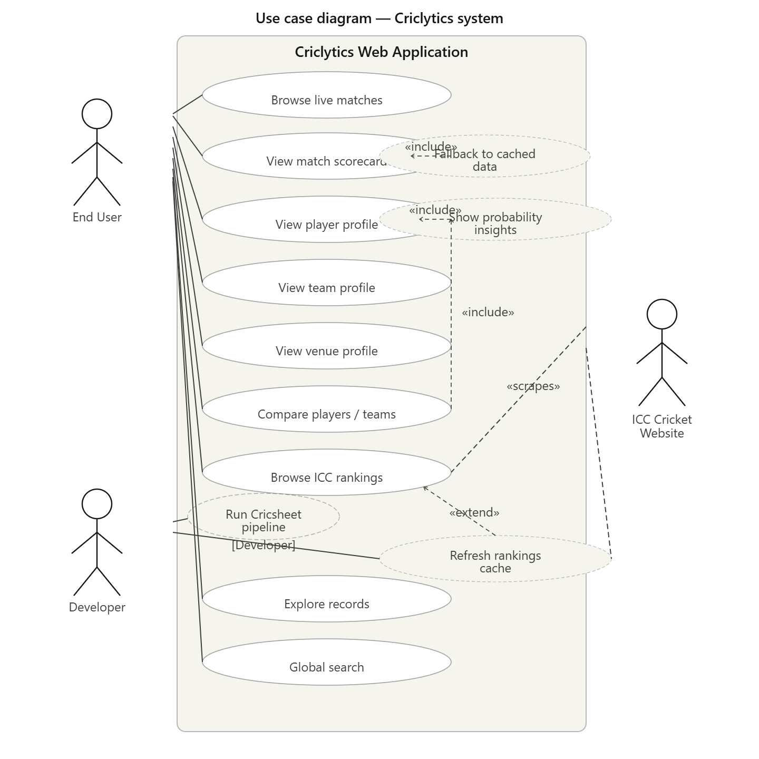

3.3 Sequence Diagrams
Sequence Diagram 1 — Player Profile Load
Lifelines: Browser/User | profile-api.js | Flask app.py | Cricsheet JSONs | players_meta.json. Shows 18 messages including parallel meta fetch, ICC rankings loop across 3 formats × 2 categories, photo async load with onerror fallback, and similar players sidebar population.

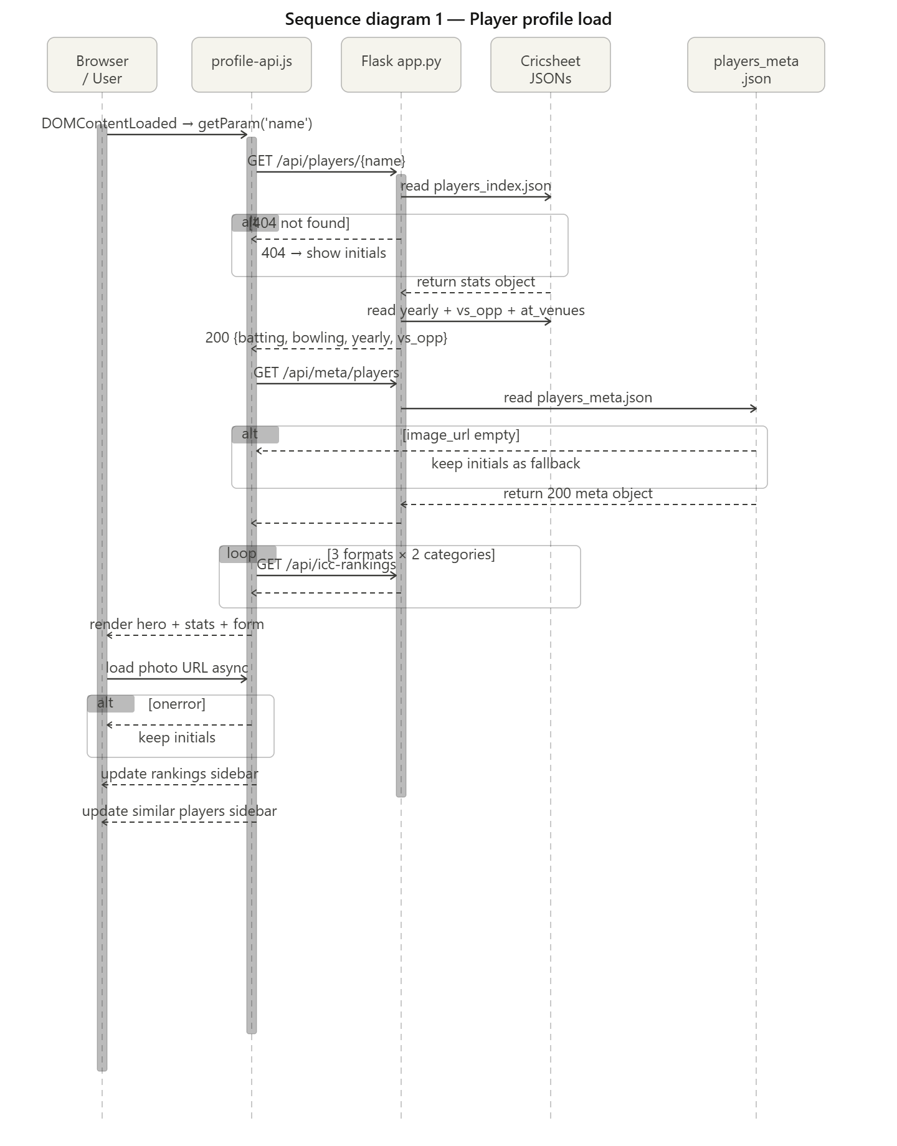

Sequence Diagram 2 — ICC Rankings with Scraper Fallback
Lifelines: Browser/User | rankings-api.js | Flask app.py | scrape_rankings.py | ICC Cricket / rankings.json. Shows the two-level fallback: cached JSON → live scrape attempt → hardcoded March 2026 data. Includes format tab switching with rankCache{} client-side caching.

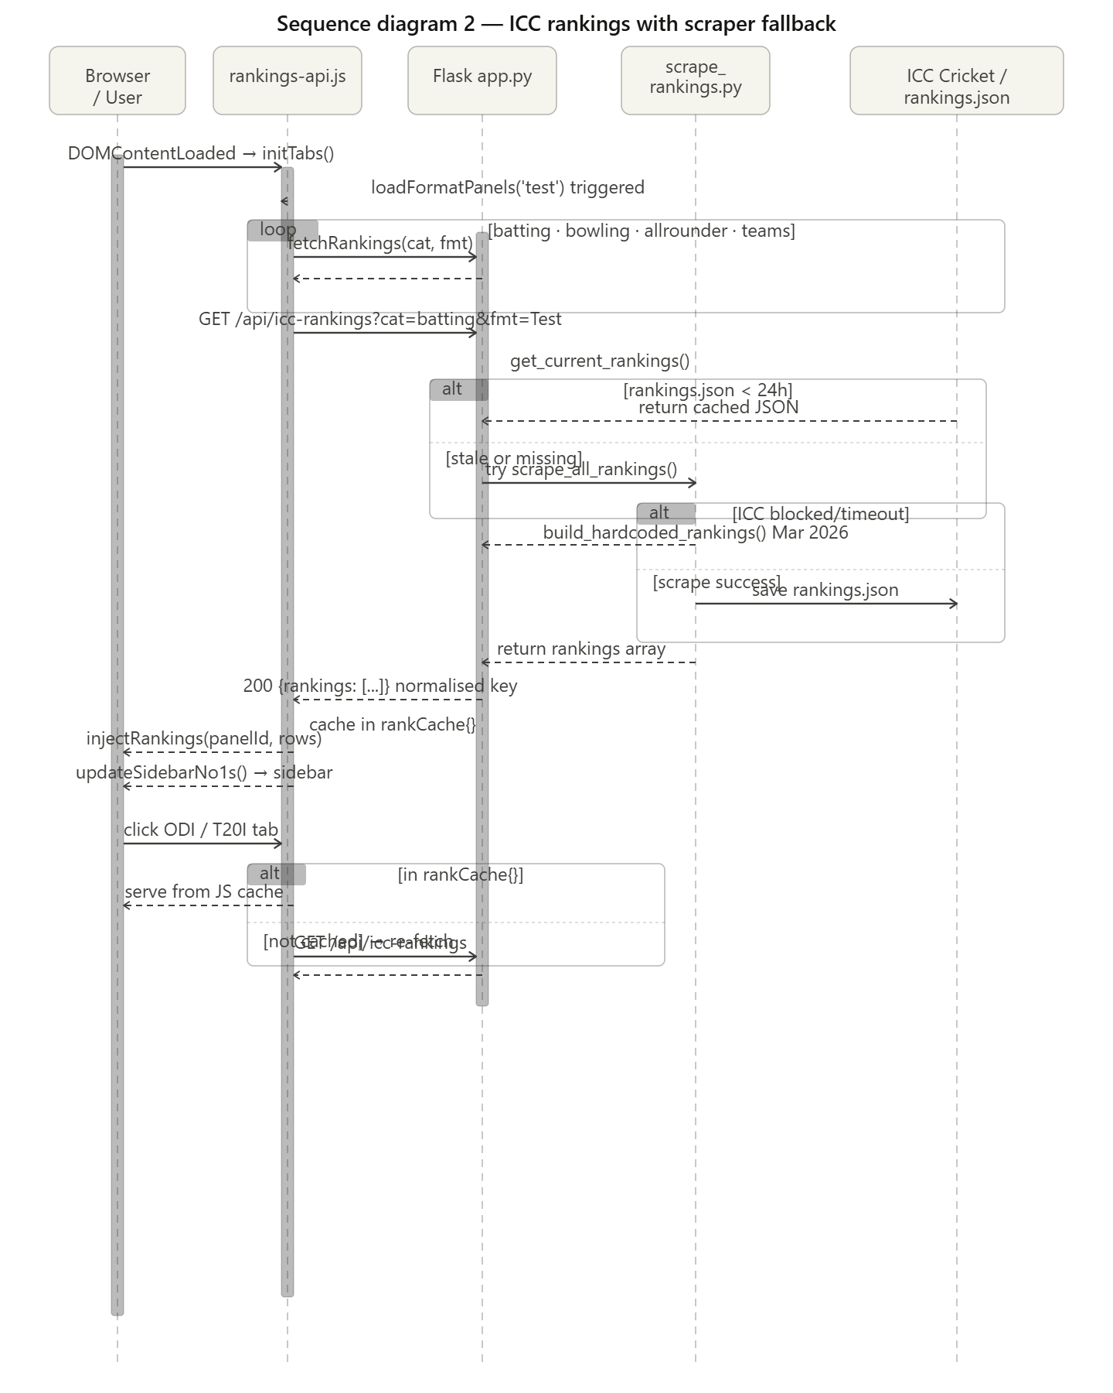

Sequence Diagram 3 — Player/Team Comparison
Lifelines: Browser/User | compare-api.js | Flask app.py | Cricsheet players_index | teams API. Covers selector population, selectItem() calls, showResults() trigger, /api/compare/players API call, client-side aggBat() cross-format aggregation, stat grid update, probability block computation, and team mode switch via /api/teams.

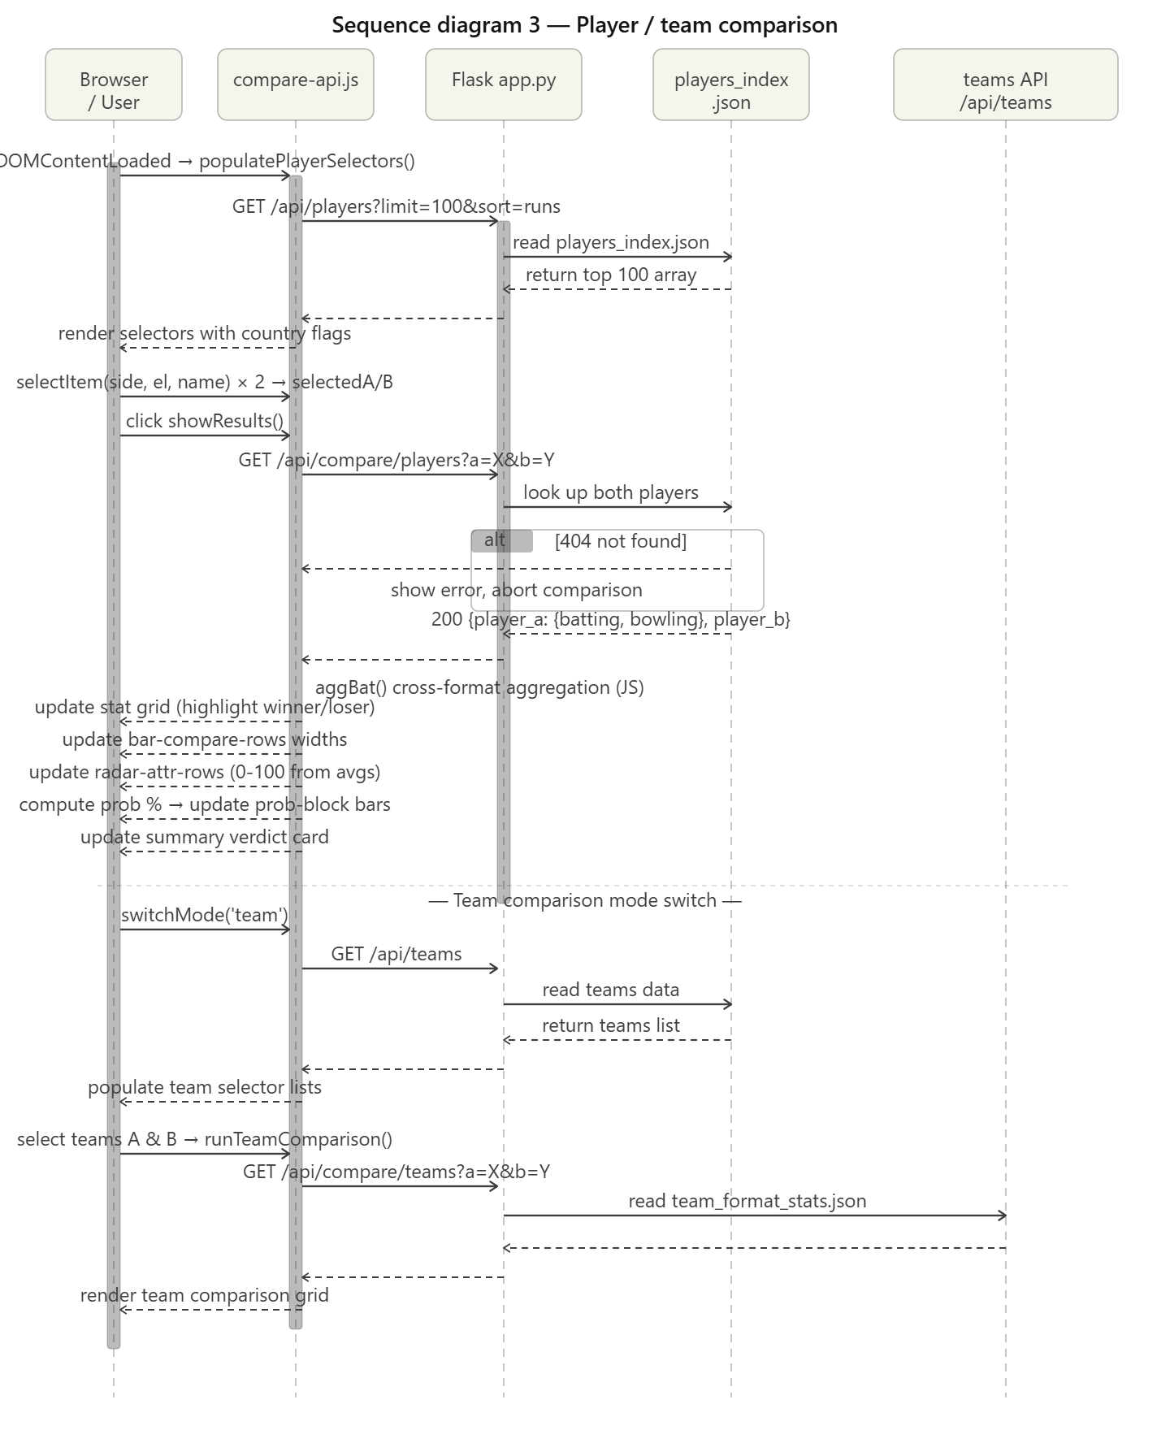

3.4 Class Diagram
The class diagram shows 10 classes across three layers: Flask backend (FlaskApp, CricsheetPipeline, RankingsScraper), domain model (Player, BattingStats, Team, Venue, Match), and JavaScript layer (CricklyticsJS, PageApiJS). Relationships shown include association (serves 1..*), aggregation (Player has BattingStats), and dependency (PageApiJS uses CricklyticsJS).

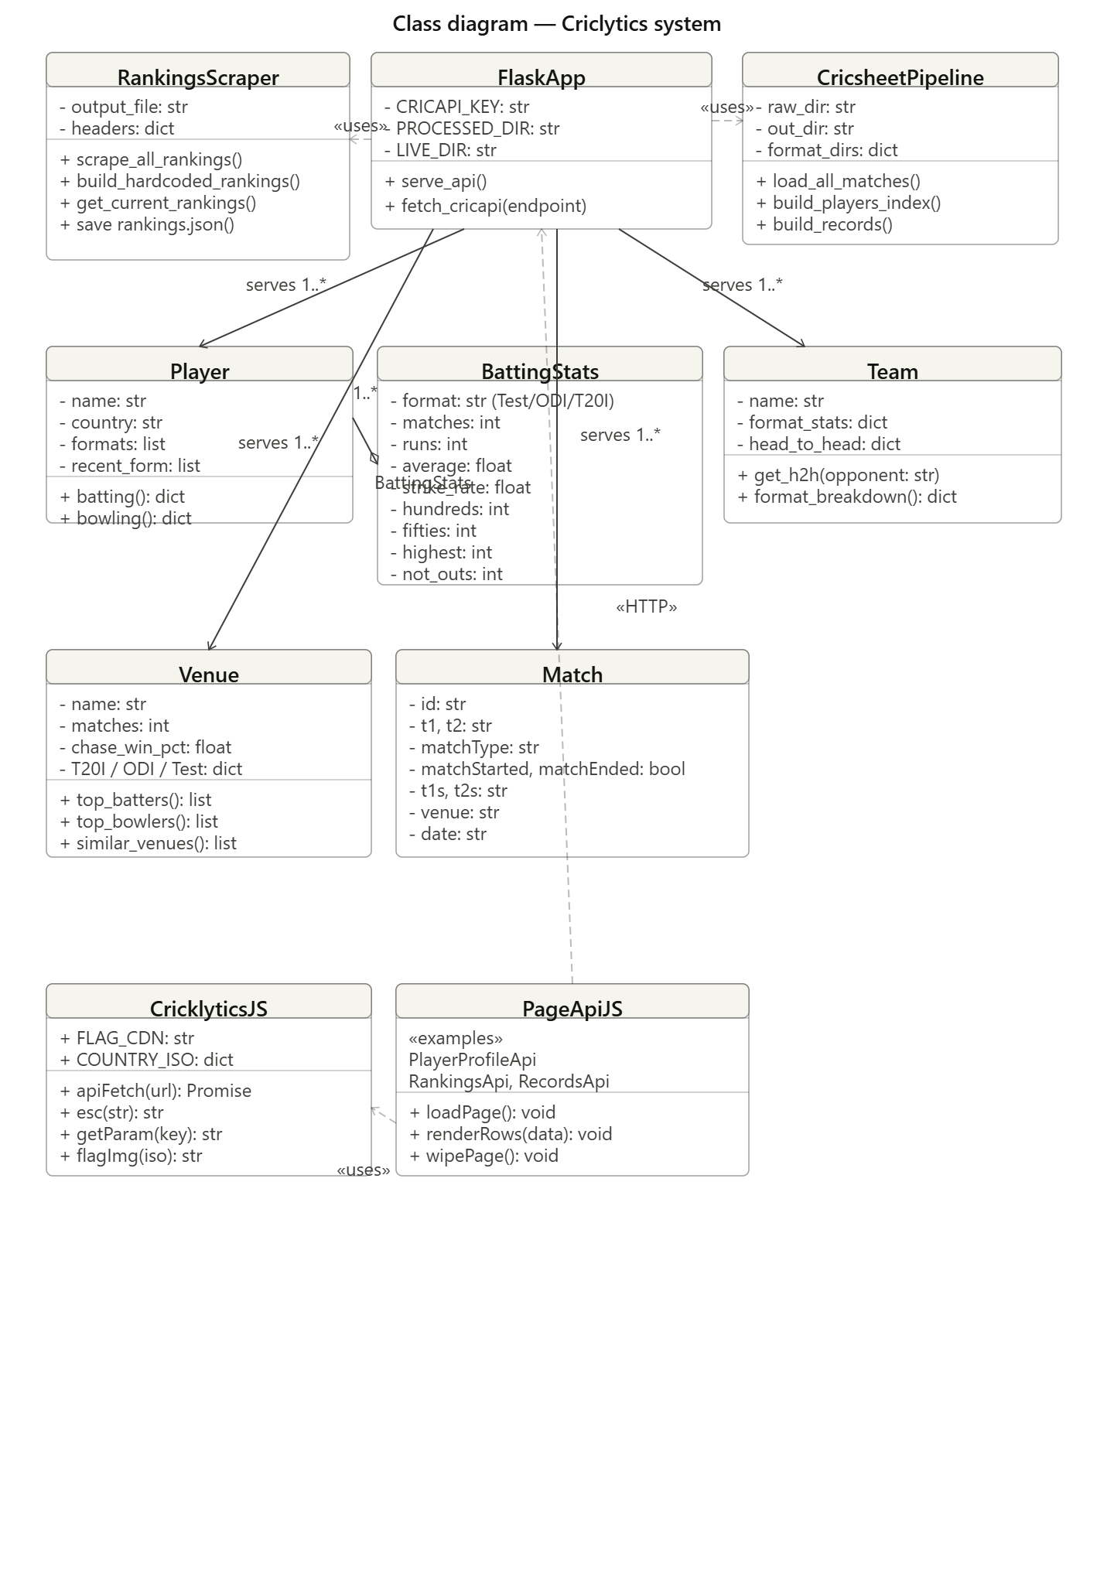

4. Architecture

4.1 Chosen Architecture Pattern
Cricklytics employs a Layered Architecture combined with a Pipe-and-Filter data pipeline pattern. The system is split into a fully decoupled client-server structure with four distinct backend layers.

Layer | Responsibility | Technologies
Presentation Layer | Rendering HTML pages, CSS styling, client-side interactivity | HTML5, CSS3, Vanilla JS
API Layer | REST endpoint routing, request/response handling | Flask (app.py Routes)
Service / Logic Layer | ML inference, statistical calculation, fallback chain management | ml_models.py, ml_probability_engine.py
Data Layer | JSON-based storage, ETL pipeline, Mega-Enrichment | process_cricsheet.py, completed_matches.json

4.2 Architectural Styles
A. Client-Server Architecture
The system is built as a decoupled client-server application. The frontend is a "thick client" that handles rendering logic, while the backend is a stateless REST API. This allows the frontend to be hosted on static platforms (Cloudflare Workers) while the backend runs on specialized Python environments (Hugging Face Spaces).
B. Layered Architecture
The backend follows a strict 4-layer separation of concerns to ensure maintainability, testability, and clear responsibility boundaries. Each layer communicates only with the layer directly below it.
C. Pipe-and-Filter (Data Pipeline)
The ingestion of cricket data follows the pipe-and-filter pattern. Raw Cricsheet JSON is passed through a series of filters in process_cricsheet.py (Parsing → Aggregation → Mega-Enrichment → Compression) before landing in the optimized production sink (completed_matches.json).

4.3 Production Strategy: Mega-Enrichment
To solve the "Too Many Files" problem in production, the architecture was evolved to use a Pre-Enriched Static Data Model. Instead of the server fetching raw data on-demand, all necessary details (scorecards, officials, partnerships) are pre-baked into the main match index. This shifts the computational load from Request-Time to Build-Time, achieving O(1) lookups instead of O(N) on-the-fly joins.

4.4 Architecture Diagram

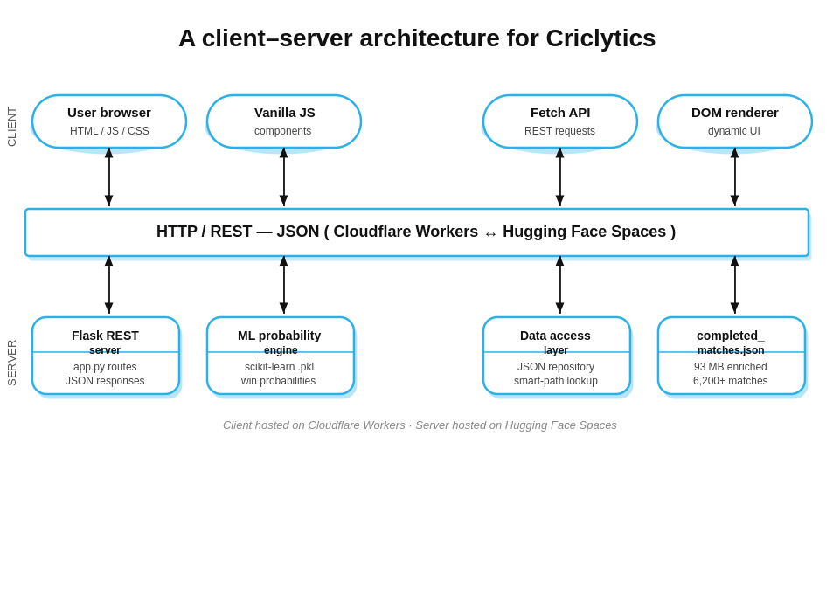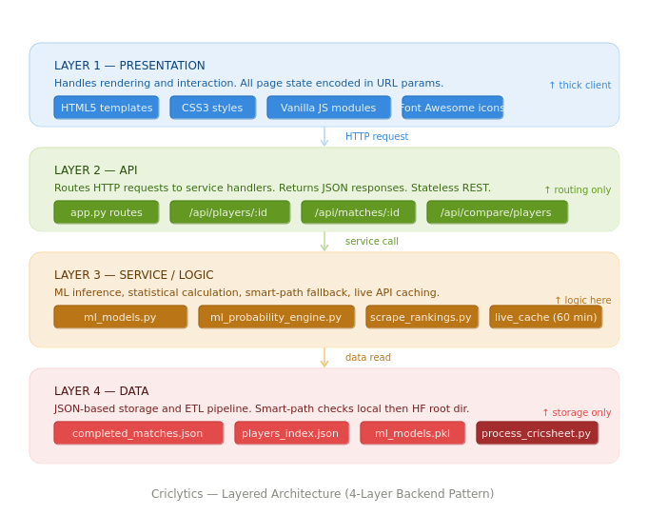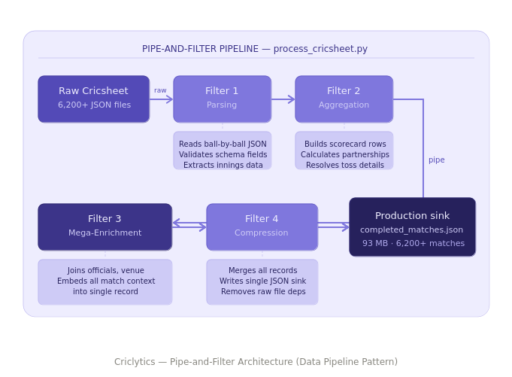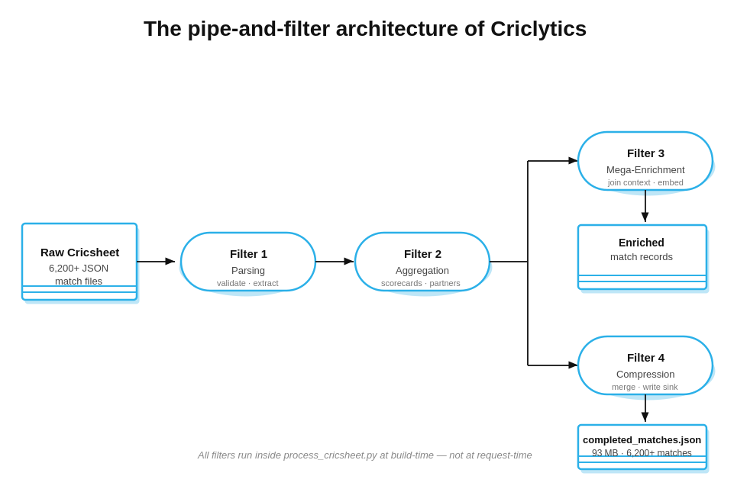

5. Implementation — GUI

5.1 Live Website
The Cricklytics platform is deployed and publicly accessible at the following URL:

Website: https://criclytics.aliamirchoudhary.workers.dev/

Scan the QR code below to access the platform directly on a mobile device:



5.2 Implementation Screenshots
The following screenshots demonstrate the fully implemented and deployed Criclytics platform. All 15 pages of the application are shown below.

Screenshot 1 — Home Page
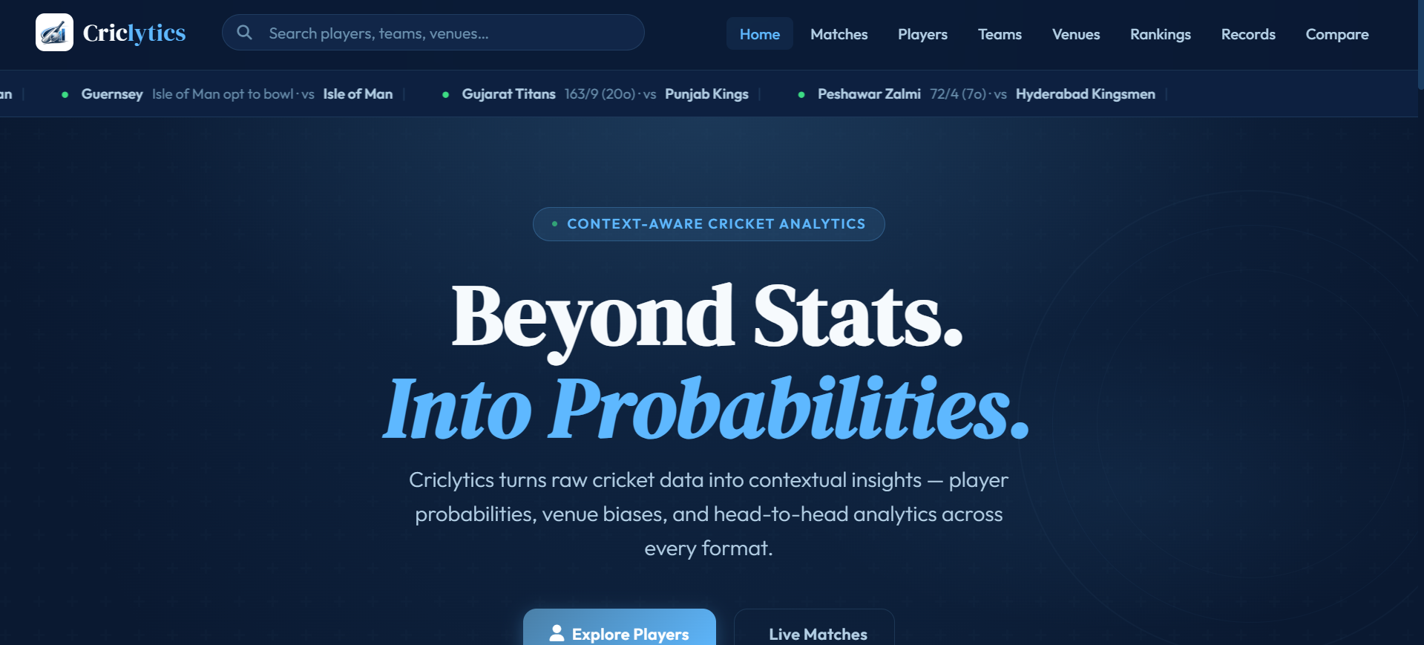

Screenshot 2 — Matches Listing
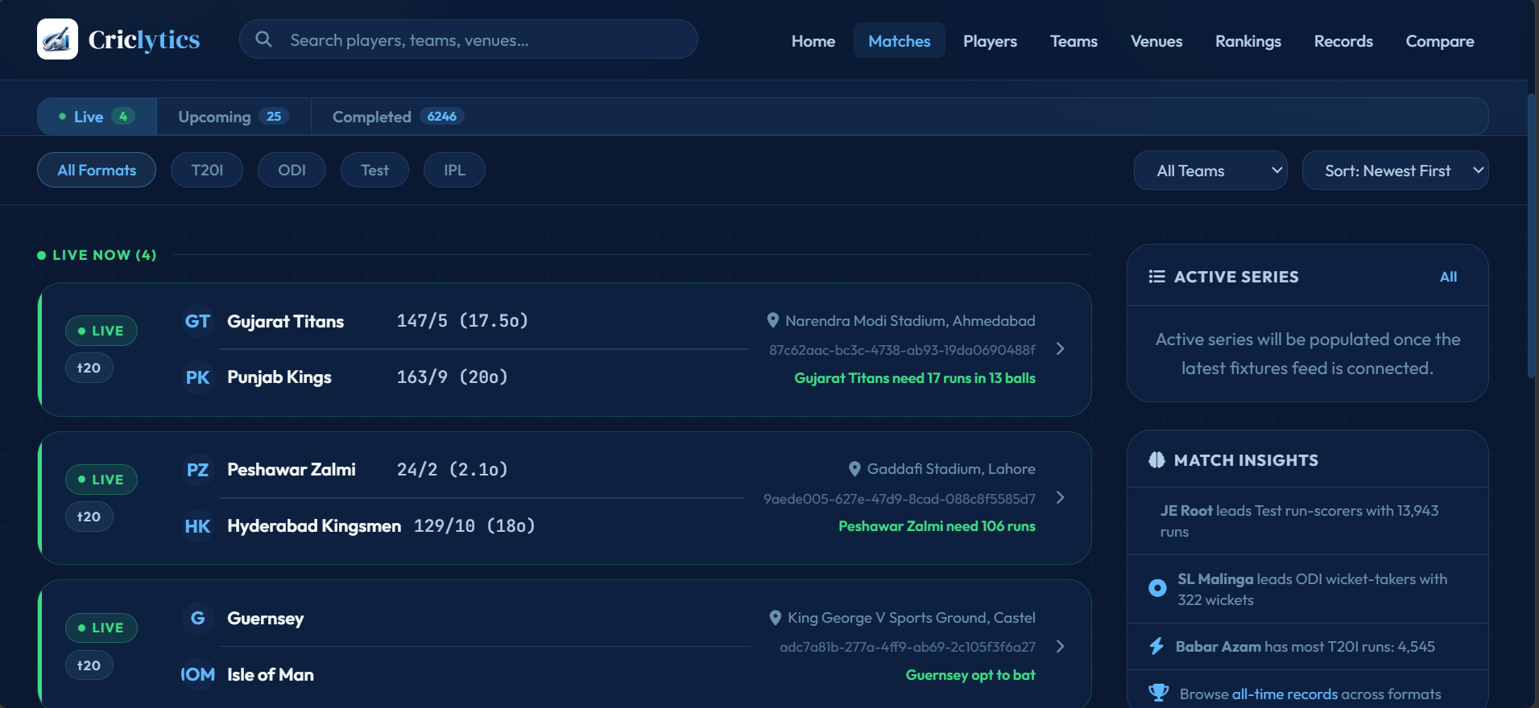

Screenshot 3 — Match Detail Page
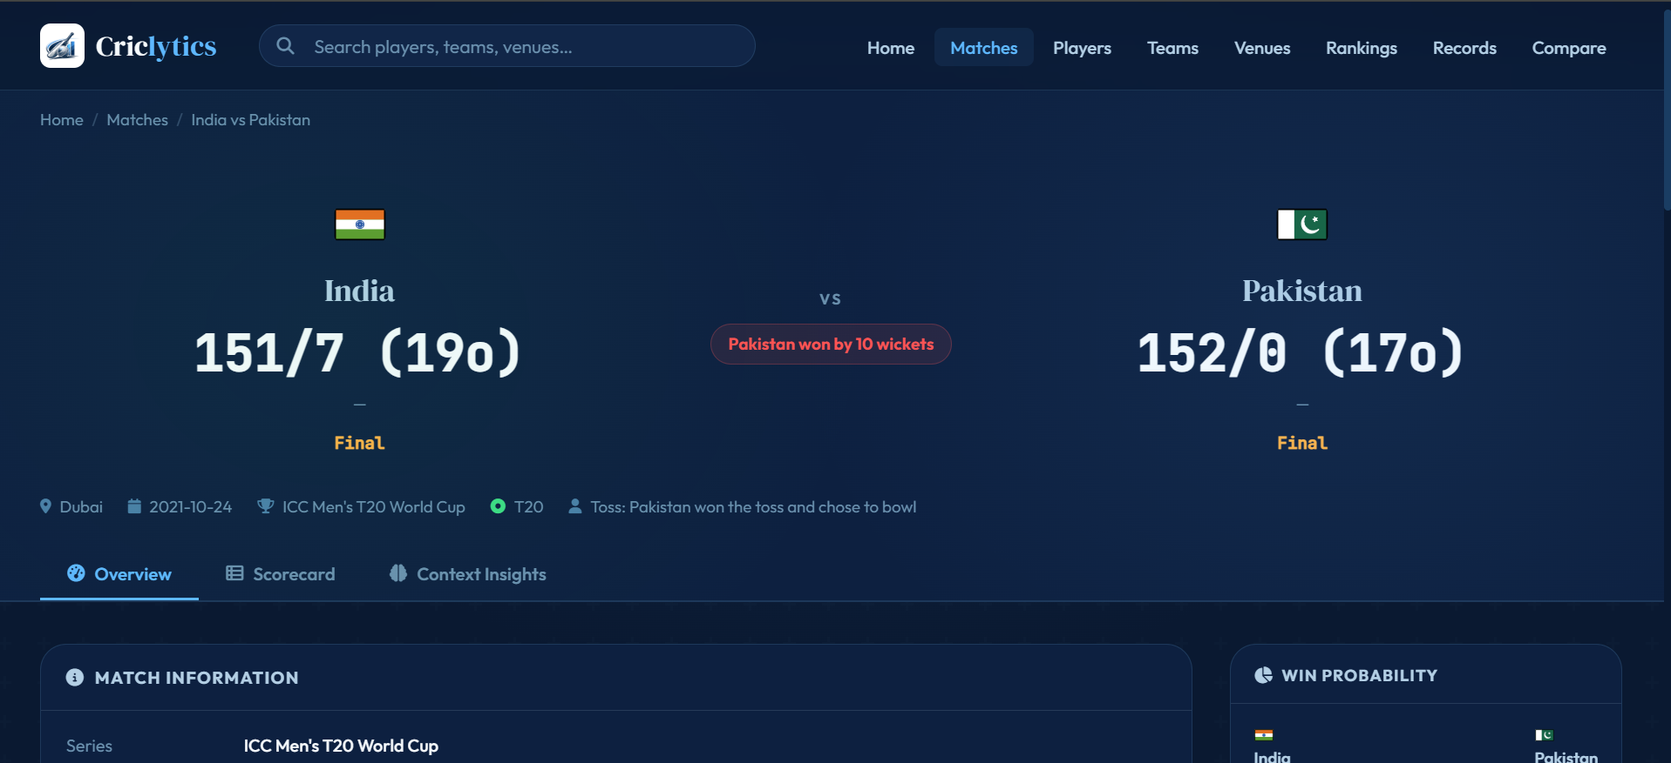 | 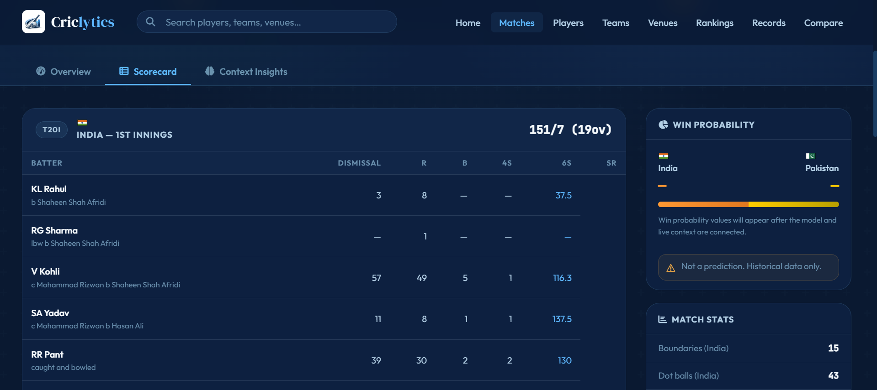

Screenshot 4 — Players Listing
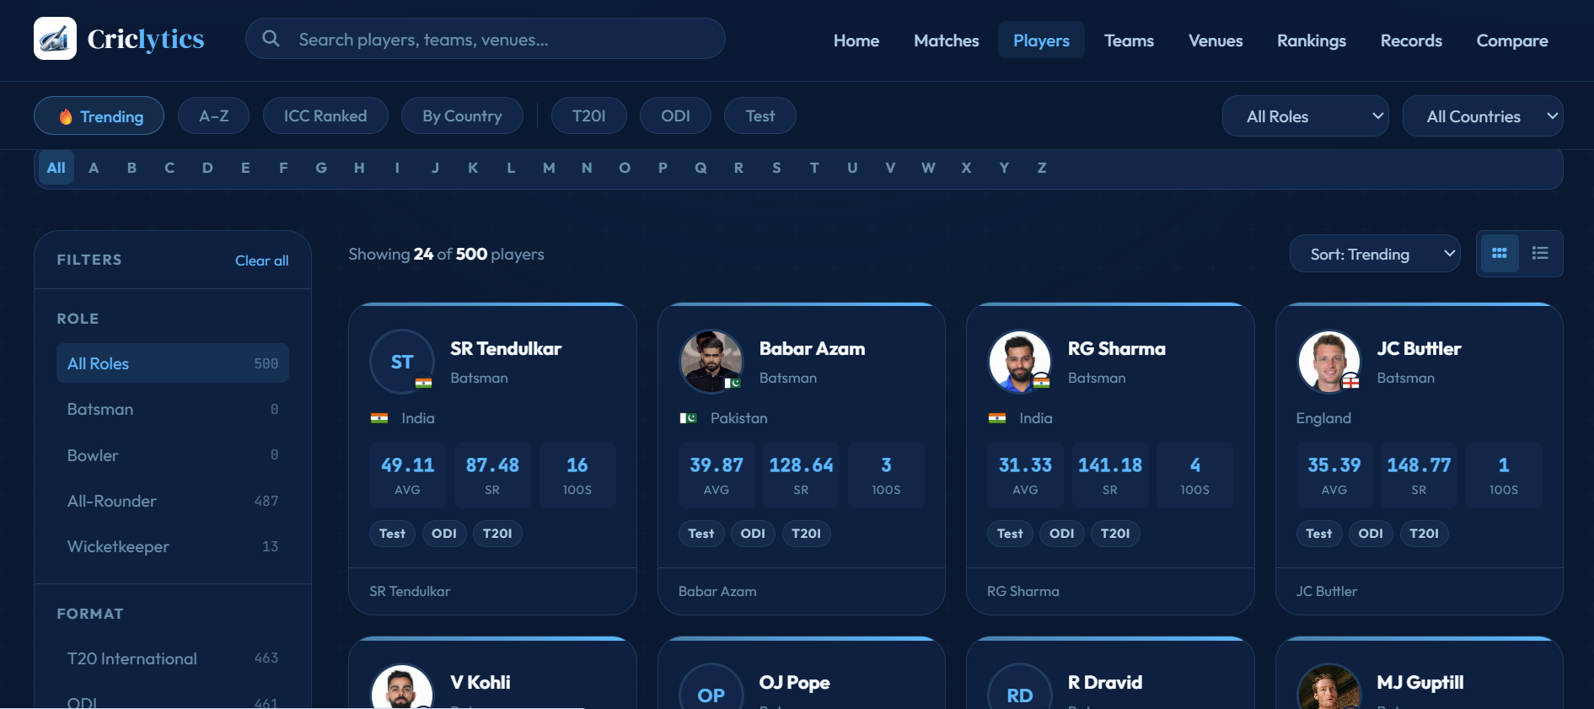

Screenshot 5 — Player Profile
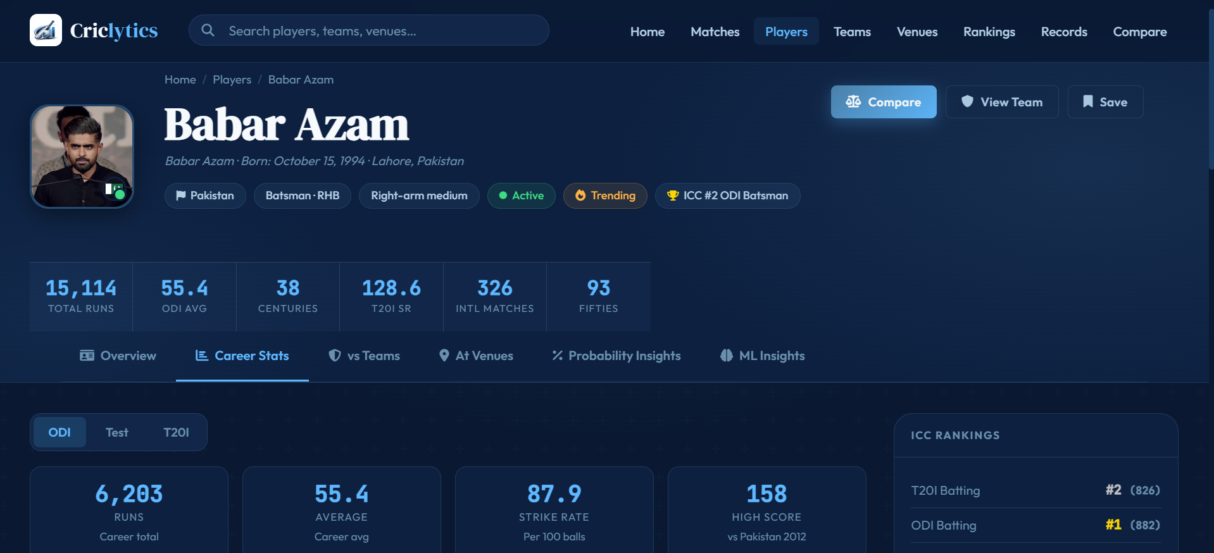 | 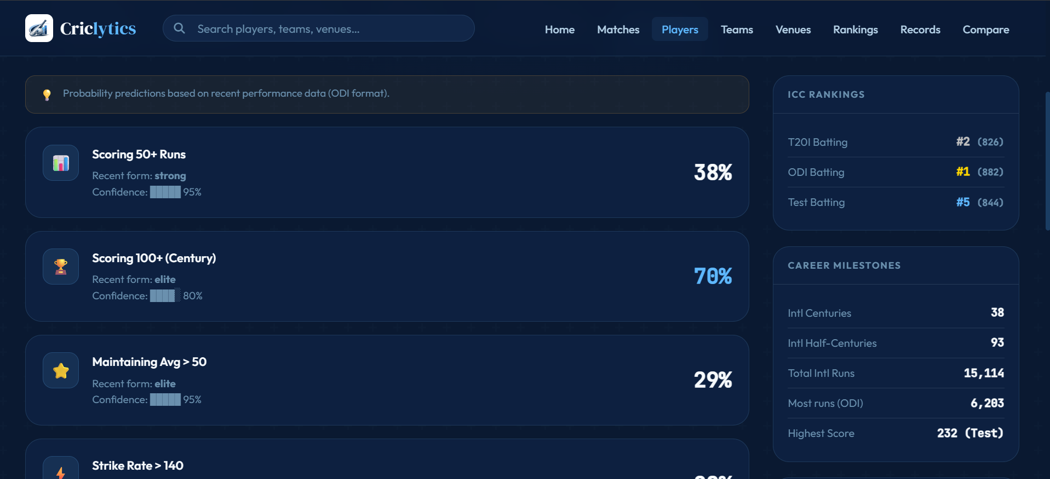

Screenshot 6 — Teams Module
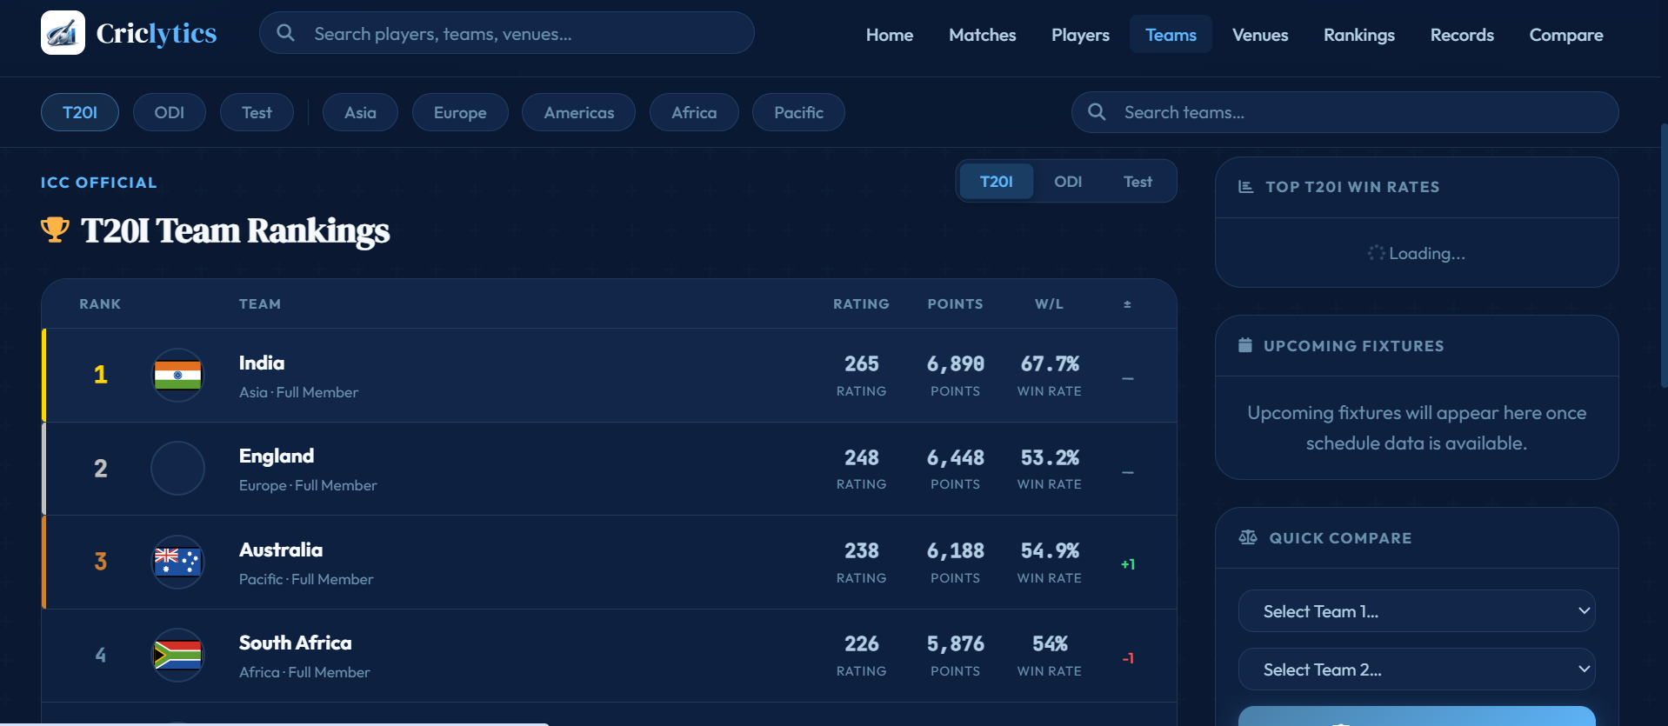

Screenshot 7 — Venues Module
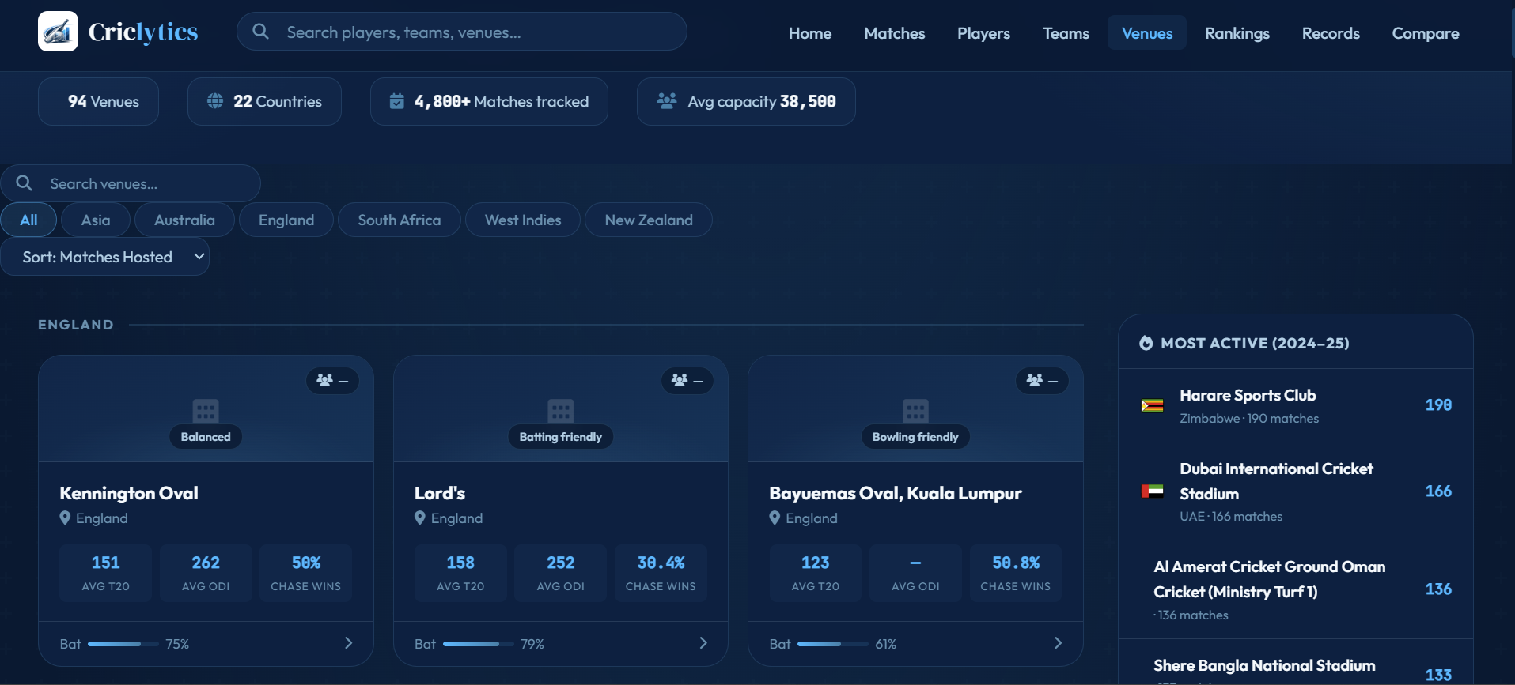

Screenshot 8 — Compare Tool (Player)
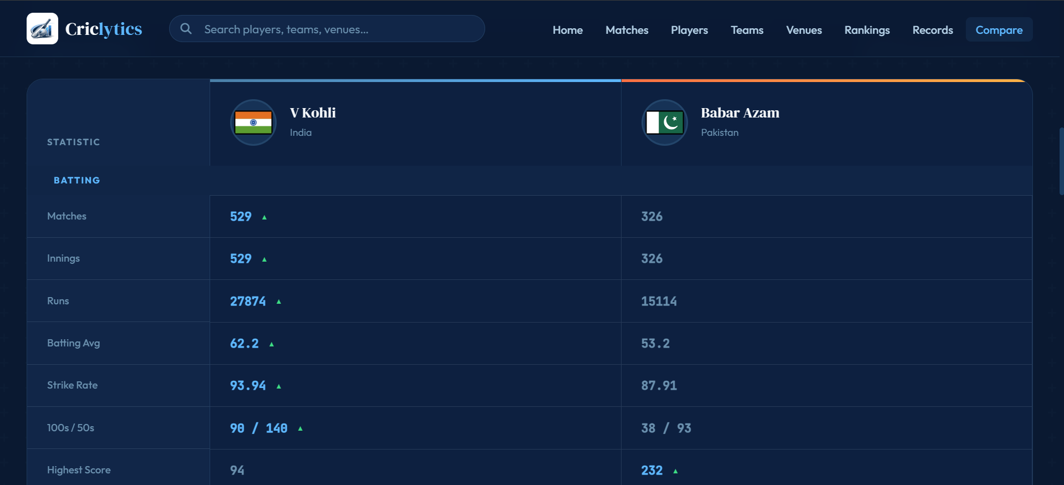

Screenshot 9 — Compare Tool (Team)
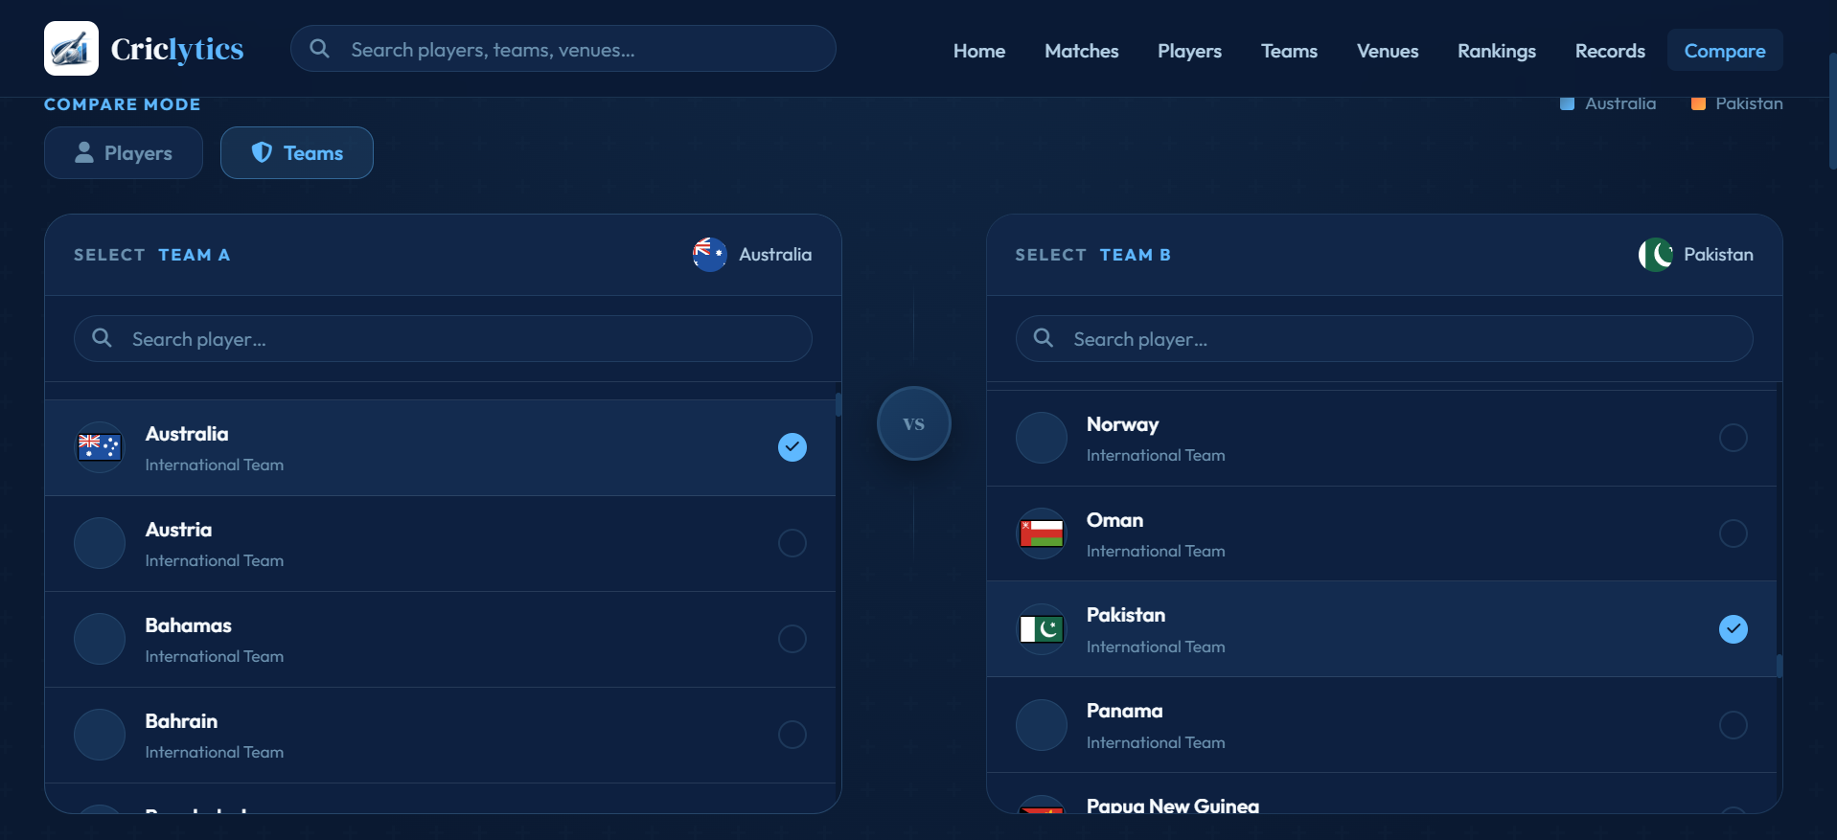

Screenshot 10 — Rankings Page
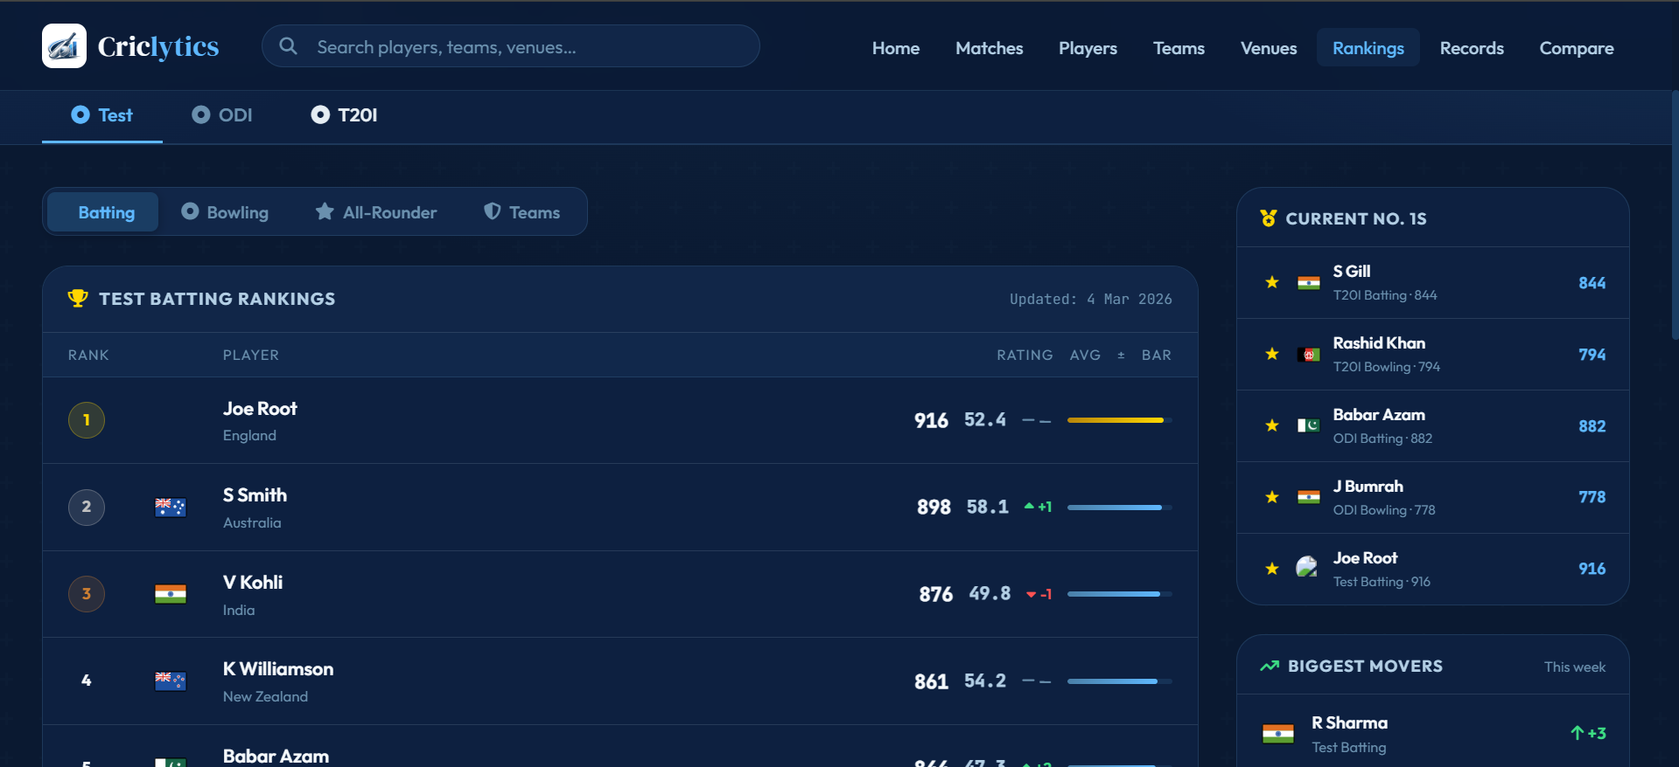 | 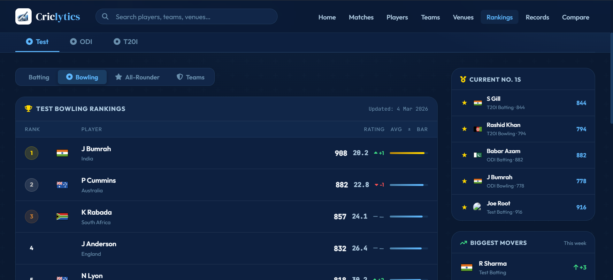

Screenshot 11 — Records Page
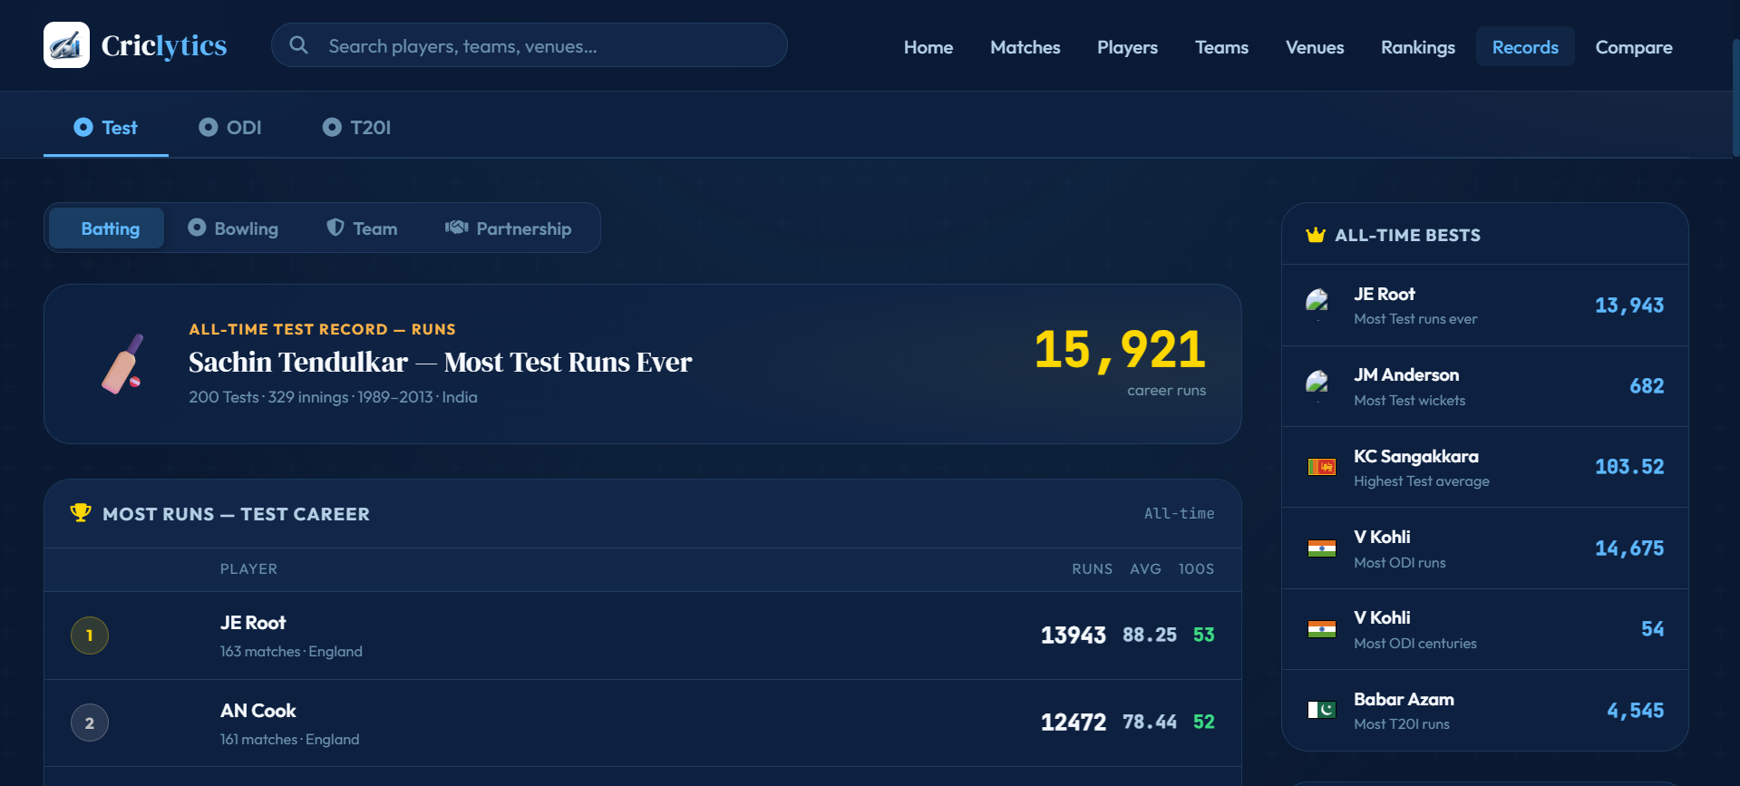

Screenshot 12 — Global Search
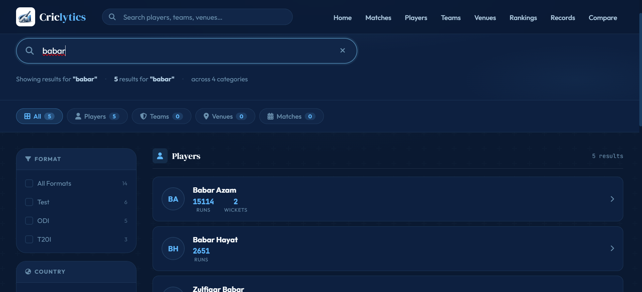

Screenshot 13 — Mobile Responsive View
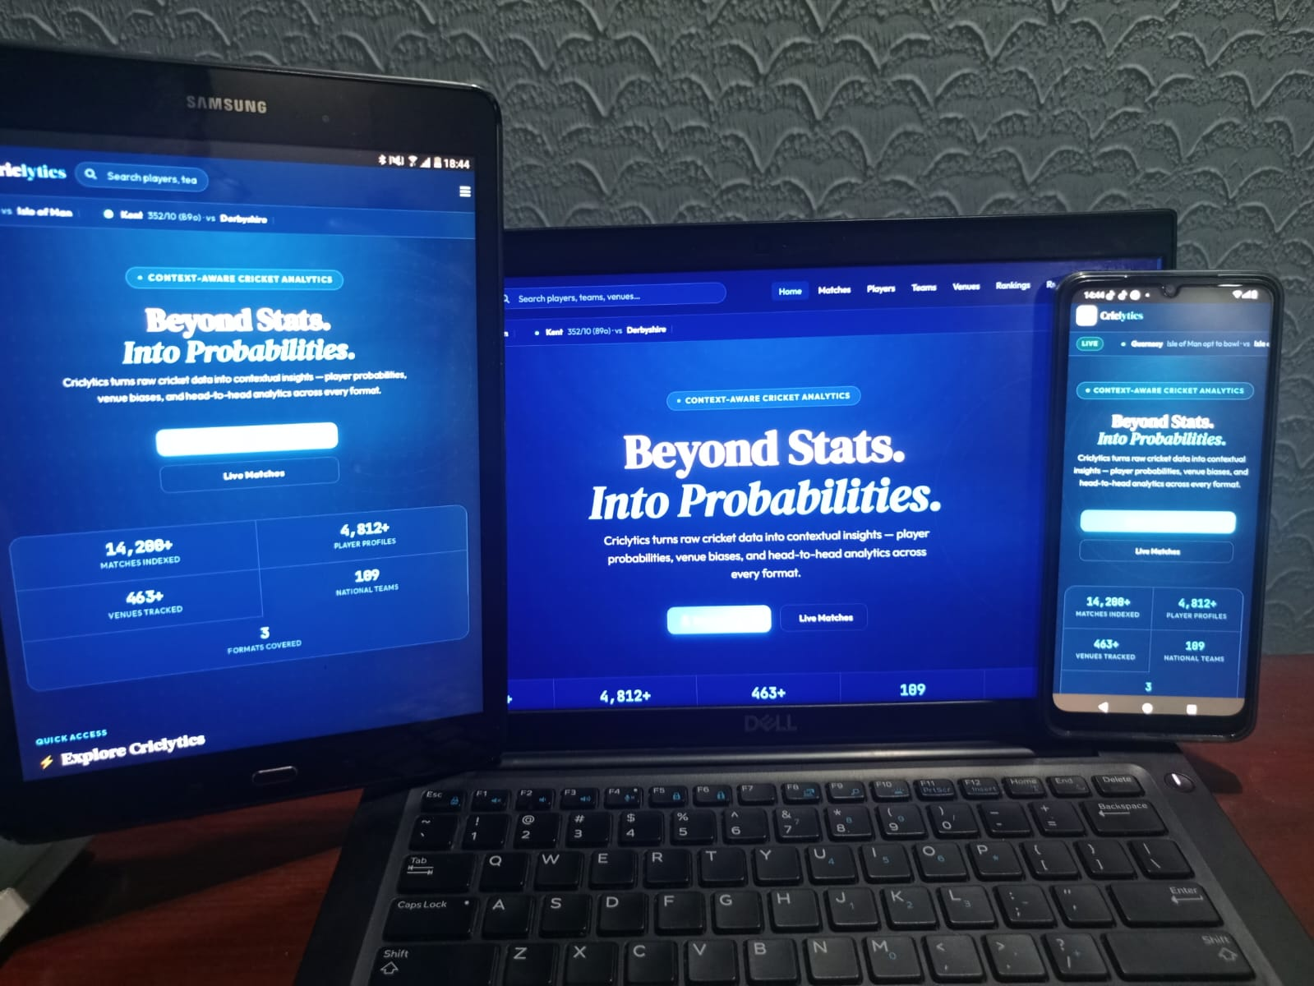

Screenshot 15 — Hugging Face Deployment
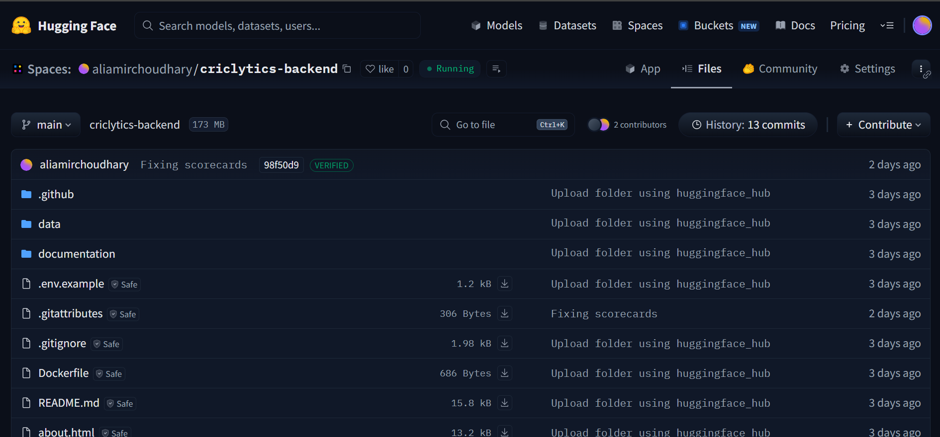

6. Product Burn Down Chart
The burn down chart below tracks the total remaining story points across all three sprints against the ideal burn rate.

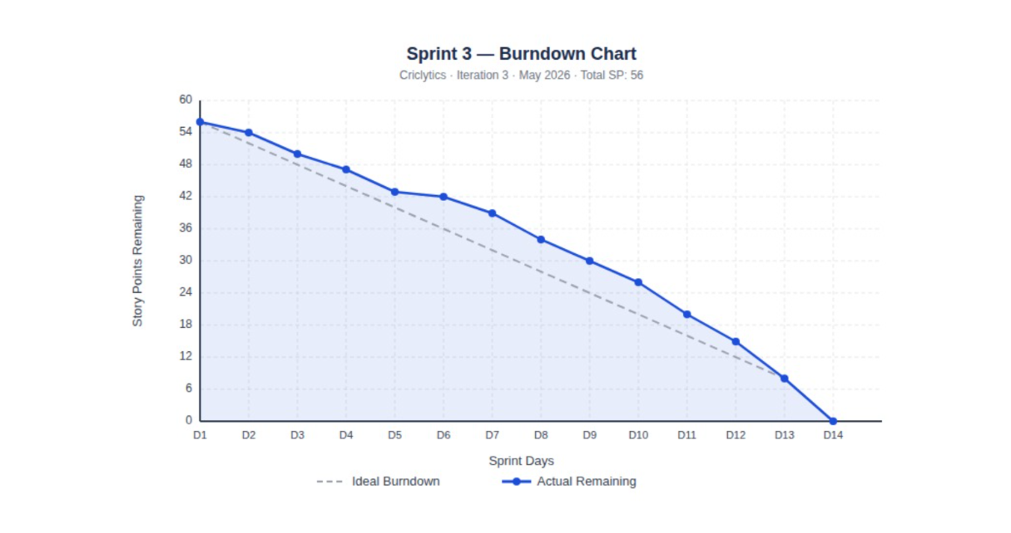

7. Trello Board — Sprint 3
The Trello board screenshots below show the Sprint 3 task progression from Backlog → In Progress → Done.
Start:
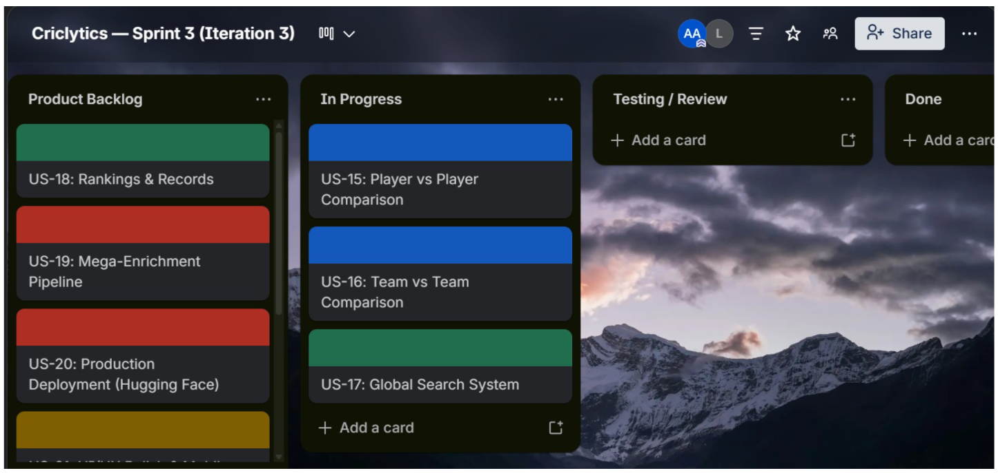

50%:
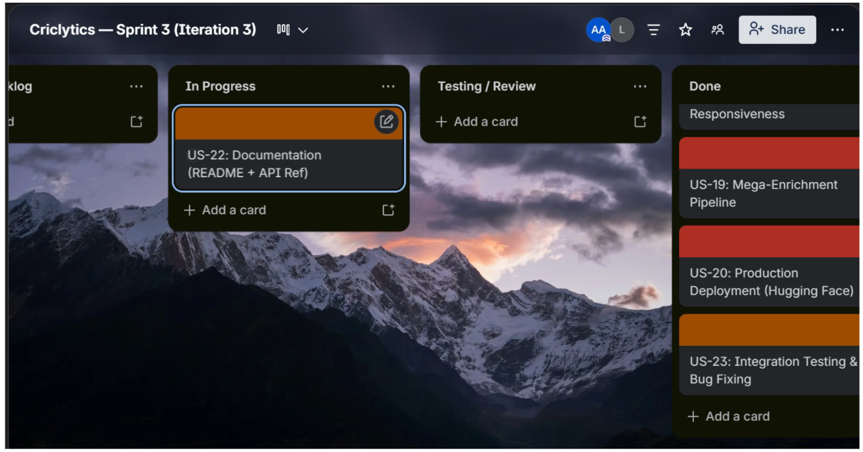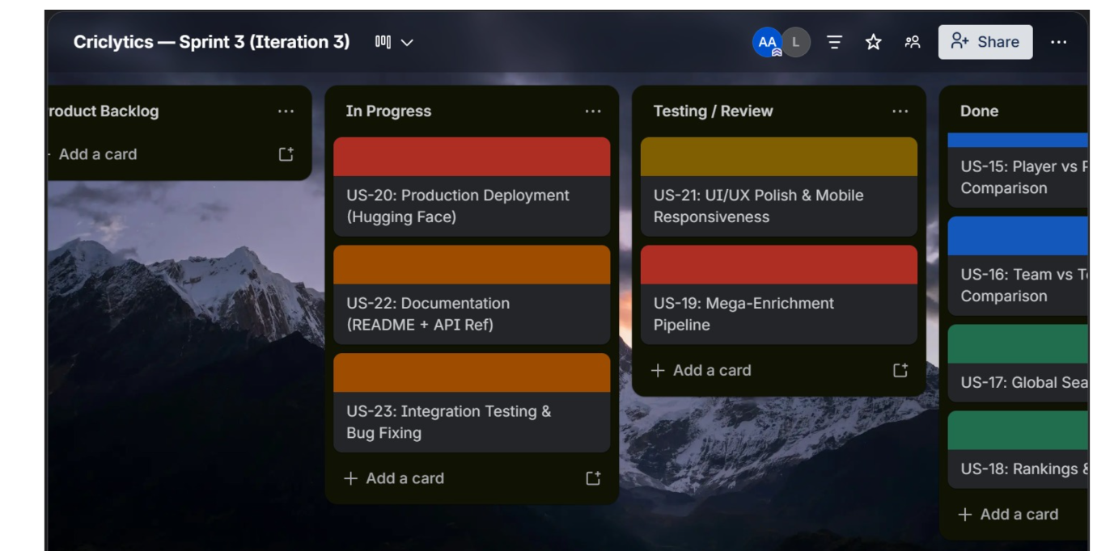

8. Boundary Value Analysis Testing

8.1 What is Boundary Value Analysis?
Boundary Value Analysis (BVA) is a black-box testing technique that focuses on testing the values at the boundaries of input domains — where logic is most likely to fail. Instead of testing random values, BVA targets the minimum (x_min), just above minimum (x_min+), nominal middle (x_nom), just below maximum (x_max-), and maximum (x_max) values of any input range.

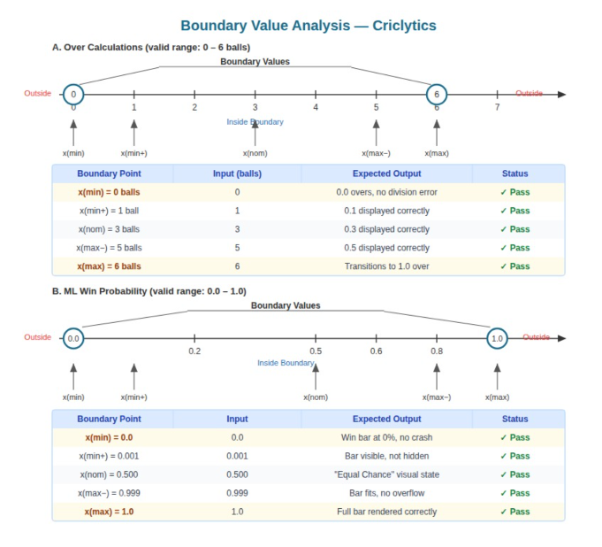

8.2 Equivalence Partitioning + BVA
Equivalence Partitioning (EP) complements BVA by dividing inputs into classes (valid and invalid partitions) where one representative value stands for the whole class. BVA is then applied to the boundaries between those partitions. In BVA, you check boundary values like x(min), x(min+), x(nom), x(max-), and x(max).

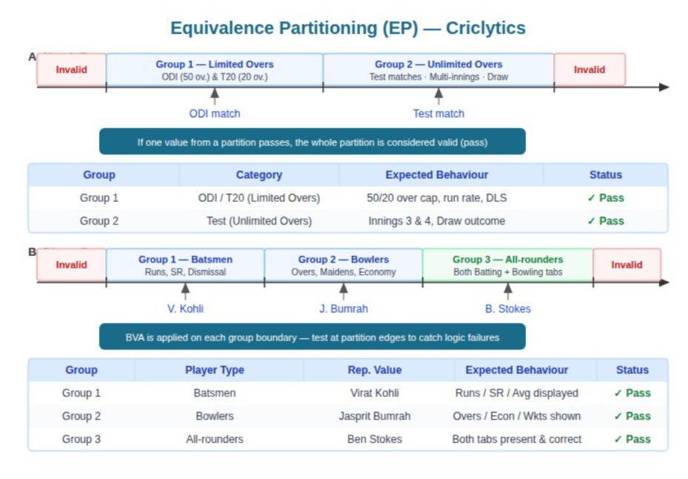

8.3 BVA Test Cases — Criclytics
A. Over Calculations (Ball Counter)
The standard over boundary is 6 legal balls. The ball counter must transition correctly at each boundary.

Test ID | Input (Balls) | Boundary Type | Expected Output | Result
BVA-01 | 0 balls | x_min | Displays 0.0; no division error on new innings | Pass
BVA-02 | 1 ball | x_min+ | Displays 0.1 | Pass
BVA-03 | 3 balls | x_nom | Displays 0.3 | Pass
BVA-04 | 5 balls | x_max- | Displays 0.5 | Pass
BVA-05 | 6 balls | x_max | Logic transitions to 1.0 (new over) | Pass

B. ML Win Probability Output
All ML predictions must fall strictly within the [0, 1] range. The Win Probability Bar in the UI must render correctly at all extremes.

Test ID | Input (Probability) | Boundary Type | Expected UI Behaviour | Result
BVA-06 | 0.001 | x_min+ | Win bar renders at near-zero width without disappearing | Pass
BVA-07 | 0.500 | x_nom | Bar shows 50%; 'Equal Chance' visual state displayed | Pass
BVA-08 | 0.999 | x_max- | Bar renders at near-full width without container overflow | Pass
BVA-09 | 0.000 | x_min | Bar renders as invisible/empty, no JS error | Pass
BVA-10 | 1.000 | x_max | Bar renders at 100% width, no overflow | Pass

C. Global Search — Input Length
The search bar suppresses API calls below the minimum character threshold (2 chars) and must not crash on very long inputs.

Test ID | Input (Chars) | Boundary Type | Expected Behaviour | Result
BVA-11 | 1 character | x_min (invalid) | Search suppressed — no API call fired | Pass
BVA-12 | 2 characters | x_min+ (valid) | Search triggers correctly — API call fires | Pass
BVA-13 | 50 characters | x_nom | Search returns results within debounce window | Pass
BVA-14 | 255+ characters | x_max+ | Backend handles gracefully — no 500 error | Pass

D. Match Result Margin
Match outcomes must display the correct status text at margin boundary values, particularly for ties and narrow victories.

Test ID | Input (Margin) | Boundary Type | Expected Behaviour | Result
BVA-15 | 0 runs | x_min | Status text shows 'Tie' or 'No Result' — not '0 runs win' | Pass
BVA-16 | 1 run | x_min+ | Status text shows 'Won by 1 run' correctly | Pass
BVA-17 | Typical margin | x_nom | Standard win text rendered correctly | Pass

8.4 Equivalence Partitioning — Match Formats & Player Roles
A. Match Formats
Partition | Representative Values | Logic Applied | Result
Group 1 — Limited Overs | ODI, T20I | 50/20 over cap, run-rate calculation, no draw outcome | Pass
Group 2 — Unlimited Overs | Test Match | Multiple innings (3rd, 4th), 'Draw' outcome handling | Pass

B. Player Roles
Partition | Representative Values | Data Required | Result
Group 1 — Batsmen | Top-order batters | Runs, Strike Rate, dismissal data visible | Pass
Group 2 — Bowlers | Fast/spin bowlers | Overs, Maidens, Economy data visible | Pass
Group 3 — All-rounders | Dual-role players | Both batting and bowling scorecard tabs render | Pass

9. Work Division

Task / Module | Muhammad Ali Aamir (24L-2558) | Muhammad Mahad Mahmood (24L-2548)
Player vs Player Comparison | Backend API (/api/compare/players), ML probability bars | Frontend UI, format tabs, stat grid highlighting
Team vs Team Comparison | H2H data aggregation, venue-specific win logic | Frontend UI, win/loss visualization, format switching
Global Search System | Flask /api/search endpoint, categorized indexing | Frontend search bar, debouncing, result rendering
Rankings & Records | ICC rankings scraper, Cricsheet records aggregation | Frontend ranking panels, medal styling, records filter UI
Mega-Enrichment Pipeline | process_cricsheet.py mega-enrichment logic, completed_matches.json generation | Smart path fallback logic in app.py, ml_models.py, testing
Production Deployment | Hugging Face Spaces setup, Git cleanup, .gitignore | Manual large-file uploads (HF Web Interface), environment config
UI/UX Polish | Dark-mode CSS system, card layouts, mobile breakpoints | Cross-page visual consistency, disclaimer widgets, QA
Documentation & Testing | README.md, API reference, BVA test case design | Inline code comments, integration & regression testing, BVA execution

10. Lessons Learned

Lesson 1 — "Git is not a Database"
We initially struggled with repository size limits when trying to commit thousands of raw Cricsheet JSON files. We learned that for large-scale data applications, Git should only track code, while data must be managed via automated build pipelines and manual production uploads. The introduction of .gitignore rules for data/live/*.json and using git rm --cached for large historical files was a key turning point in keeping the repository clean and deployable.

Lesson 2 — The Power of Pre-Computation (Mega-Enrichment)
We discovered that lazily loading thousands of raw files on a production server is a recipe for 500 errors and unacceptable latency. The breakthrough was the Mega-Enrichment pipeline — moving the heavy computational lifting (scorecard aggregation, partnership calculation, toss details joining) from request-time to an offline build-time process. This single architectural decision reduced server-side response times dramatically and made the 93MB completed_matches.json the cornerstone of our production strategy.

Lesson 3 — UX Empathy: Context-Aware UI
We realized early in testing that displaying live UI elements (current bowler stats, live run rate) on completed historical matches confuses users. The implementation of Context-Aware UI — where live sections are conditionally hidden based on match status — was a vital lesson in user empathy. Good analytics UX is not just about showing data; it is about showing the right data at the right time.

Lesson 4 — Smart Path Architecture for Multi-Environment Deployment
Deploying the same codebase on both a local development machine and Hugging Face Spaces required handling different file path conventions. We solved this by implementing a Smart Path fallback pattern in app.py, ml_models.py, and ml_probability_engine.py — checking both the local subdirectory path (data/processed/) and the production root directory (/). This pattern enabled a single unified codebase with zero environment-specific code changes.

— End of Iteration 3 Report —
Status: COMPLETED & DEPLOYED | Date: May 2026

